Nombre: _______________ Periodo: ______
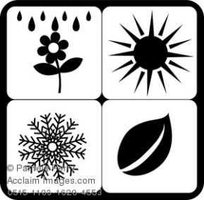
Repaso: Days, Months, Seasons

Across
1. Friday
4. Thursday
6. Saturday
8. December
9. January
10. Spring
12. July
15. September
17. Fall
19. February
21. June
22. November
Down
2. Winter
3. April
5. May
7. October
8. Sunday
11. August
13. Monday
14. Wednesday
16. March
18. Summer
20. Tuesday

