Utah Study Guide: Farming, Ranching, & Energy

- Watch the video clip about farming and write down two things you learn:
  - _______________________________________________________________________
  - _______________________________________________________________________

- What are three primary energy and natural resources within the state of Utah?
- ________________________________
- ________________________________
- ________________________________

- Fill in the blank:
Charles_________ discovered rich deposits of uranium in Moab in the 1950s. Uranium was used to help make _________ ________ during the Cold War. Moab became a boomtown as prospectors, miners, and business men moved in. Moab gradually switched from a __________ town to a __________ town.

- Bingham Copper Mine- write down two facts:
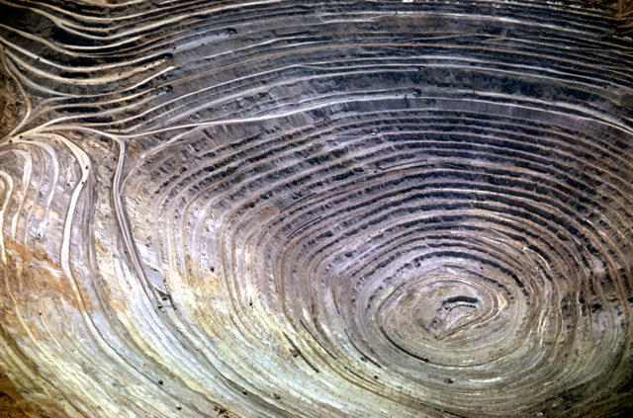

  - ____________________________________________________________________________________
  - ____________________________________________________________________________________

- How much money did Utah make in cash receipts on crops, livestock, produce etc… in 2010? ____________________________

- How many days is Northern Utah’s growing season: _______________ How many days is Southern Utah’s growing season: _______________

- List three of Utah’s primary crops:
  - ____________________________
  - ____________________________
  - ____________________________

- Describe how farming and/or ranching in Utah has affected your life: (in complete sentences)

_

