Great Depression & Roaring Twenties Study Guide

Objective: Students will analyze how the Roaring Twenties and the Great Depression influenced Utah.
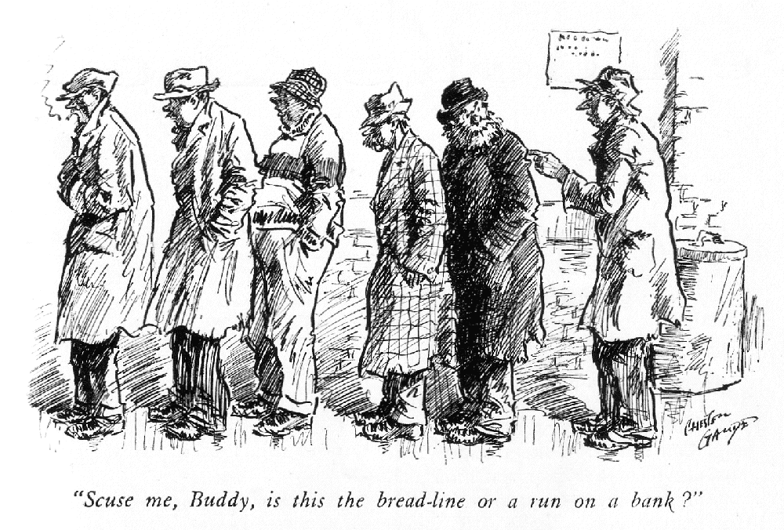
- “Brother Can You Spare A Dime?” Read the lyrics as you listen to the song. What kind of emotions does the singer mention/make you feel? Write down at least three emotions and why you think the singer feels this way:

- Great Depression: Severe worldwide, __________ depression from 1930s to middle of the 1940s.
  - Key aspects of the Great Depression:
    - Mass _____________________
    - _______________ of prices
    - ___________ ________ __________ failure (Dust Bowl)
    - Bread Lines

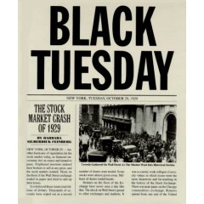

- What was the main trigger/cause of the Great Depression?
_________________________________________

Date: _______________________________

Some people called it _________ Tuesday

- How did the Great Depression impact Utah?
  - 1 in every _____ people in Utah were out of work during the Depression

  - At the height of the Great Depression, 1933, the average yearly income per Utahn was only $_______

  - Utah was one of the states hit ________ by the depression: in some counties (Duchesne & Uintah) unemployment was 75%.

  - Many parents & children searched through dumps & restaurant ________ _____
- Recovery Plans
  - Name of President Roosevelt’s plan: NEW DEAL
    - Series of economic programs put into place by President Franklin D. Roosevelt in response to the Great Depression
    - Focus on 3 R’s
    - ____________ for the unemployed & poor
    - ___________ of the economy to normal levels
    - _____________ of the financial system to prevent another depression
  - Fireside Chats

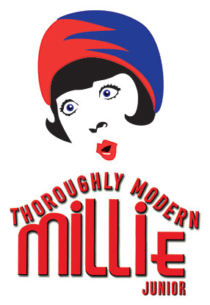
6. BEFORE the Great Depression: The Roaring Twenties
- Roaring Twenties- a time of great wealth & excess
- Women’s Suffrage: earned _______ ___ _______ in 1920
- Prohibition: attempts to ban _________

- Flappers & Jazz!
  - Charleston- popular dance of the time
  - Women__________ their hair (cut their hair short) & wore short skirts for the first time
    - Flappers: “a fashionable young woman intent on enjoying herself and behaved in bold unconventional manner.”
  - Jazz Age-jazz music & dancing become popular. Pop Culture!
  - We get to learn how to Charleston! GET EXCITED!

