Social & Religious History Unit II:
The Native American Cultures of North America.

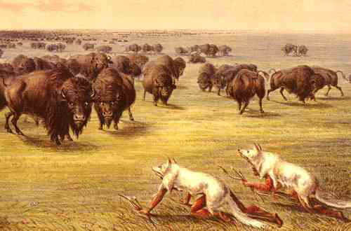

Enduring Understanding: Students will explore the myths and realities of life among various Native American Nations in North America prior to the exploration of the New World.

Essential Questions
- Students will recognize the ways Native American cultures were distinct from European cultures in the use of land and resources.
- Students will separate Native American myths (stereo-types) from realities.
- Students will identify and compare and contrast the major regional Native American Nations of North America and recognize the culture (way of life) of each.
  - Eastern Woodland Natives
  - Plains Natives
  - Southwest Natives
  - Pacific Northwest Natives
  - California (West) Natives
  - Inuit Natives

Assessments
- Essay:
At the beginning of this unit you were asked the following question: “If you could go back in time and warn the Native Americans of the impact European immigrants would have on the land, culture, people and environment of the Americas, knowing that the United States as it exists today would not be here- would you do so? What would you tell them? What advice would you give them? ECT…Explain your answer. After having studied Native American cultures would your answer be the same. Explain your answer and your reasons.

- There will be a UCUTIPS exam titled “Native Americans.” This is currently posted online.

3. Alternative assessment Native American Storyboard

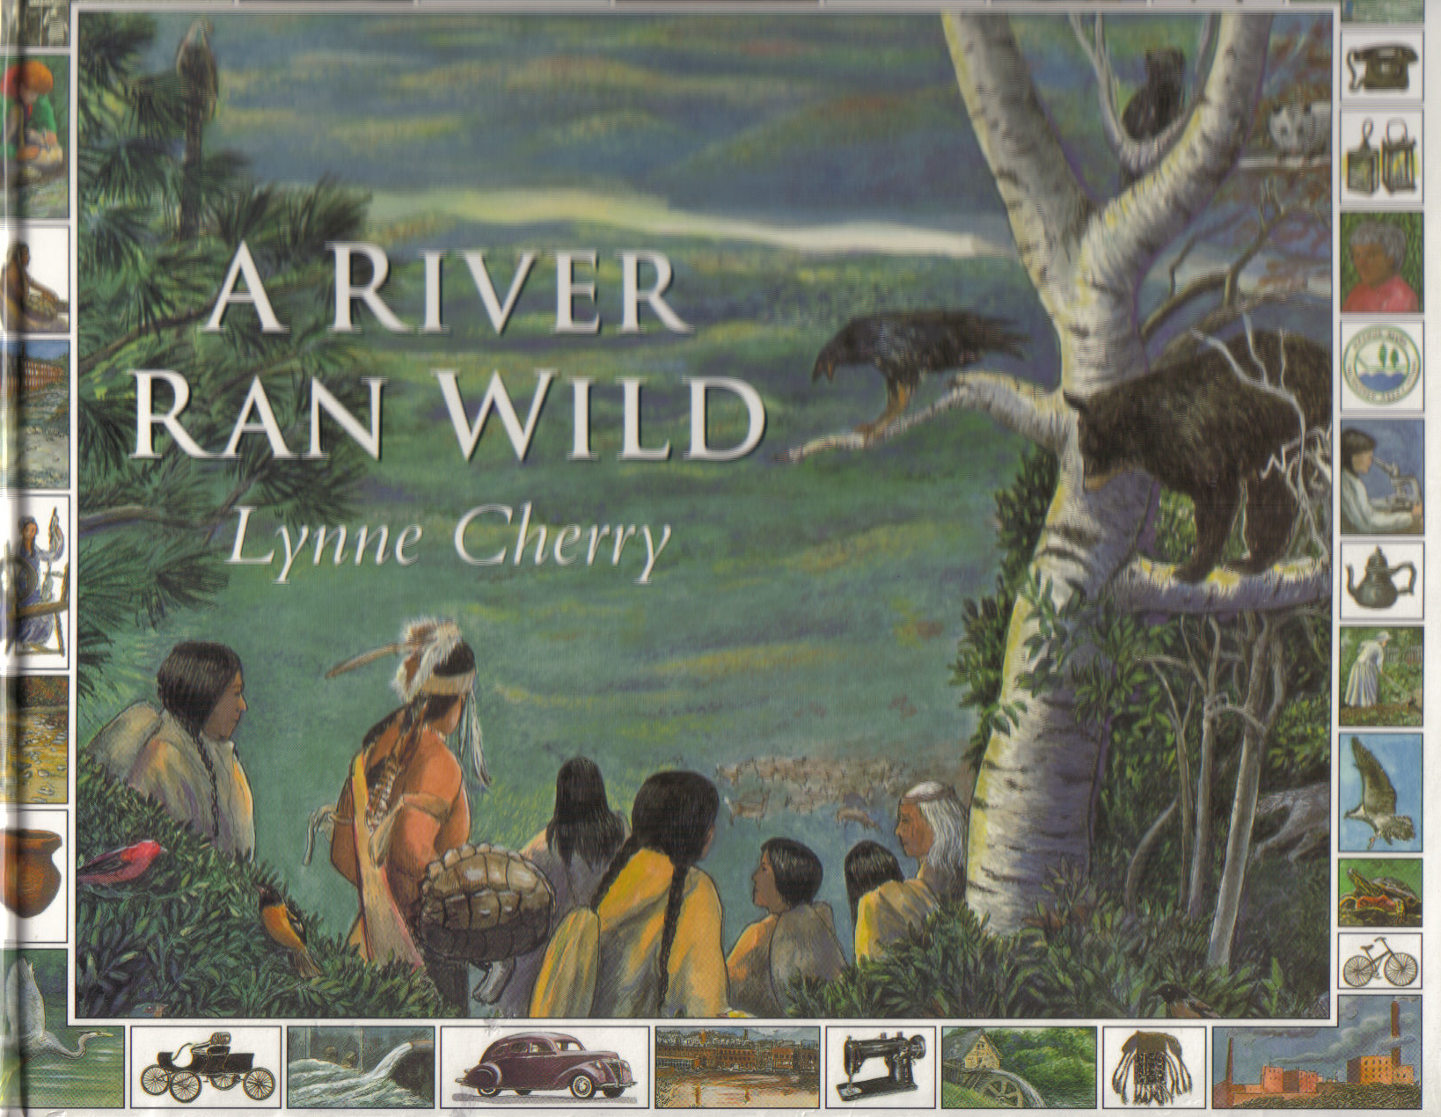
Story: Native Americans & Geography A River Ran Wild by Lynne Cherry
As you listen to the story, identify ways that you feel we could have learned from Native Americans and be prepared to answer the following Journal Write Question.

Journal Write 1:


If you could go back in time and warn the Native Americans of the impact European immigrants would have on the land, culture, people and environment of the Americas, knowing that the United States as it exists today would not be here- would you do so? What would you tell them? What advice would you give them? Etc… Explain your answer.

____________________________________________________________________________________________________________________________________________________________________________________________________________________________________________________________________________________________________________________________________________________________________________________________________________________________________________________________________________________________________________________________________________________________________________________________________________________________________________________________________________________________________________________________________________________________________________________________________________________________________________________________________________________________________________________________________________________________________________________________________________________________________________________________________________________________________________________________________
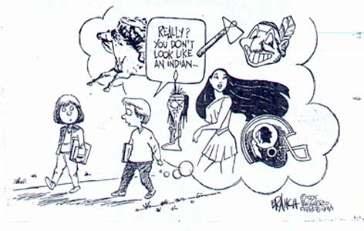
Stereotypes
How are Native Americans viewed in the media?

Declaration of Independence: In the beginning, there were negative stereotypes.

…He has excited domestic insurrections amongst us, and has endeavoured to bring on the inhabitants of our frontiers, the merciless Indian Savages, whose known rule of warfare, is an undistinguished destruction of all ages, sexes and conditions.


Why do you think Thomas Jefferson used the terms “merciless” and “savage” to refer to Native Americans? What does this show about Native American and Colonial relations?
________________________________________________________________________________________________________________________________________________________________________________________________________________________________________________________________________________________________________________________

Stereotypes: Fixed impressions exaggerated or preconceived ideas about particular social groups, usually based solely on physical appearance.

Define stereotypes in your own words. Give an example of stereotyping in our school or community. Explain your answer
________________________________________________________________________________________________________________________________________________________________________________________________________________________________

Cartoon Analysis Worksheet
Level 1
Visuals | Words (not all cartoons include words)
- List the objects or people you see in the cartoon. | - Identify the cartoon caption and/or title.  - Locate three words or phrases used by the cartoonist to identify objects or people within the cartoon.  - Record any important dates or numbers that appear in the cartoon.
Level 2
Visuals | Words
- Which of the objects on your list are symbols?  - What do you think each symbol means? | - Which words or phrases in the cartoon appear to be the most significant? Why do you think so?  - List adjectives that describe the emotions portrayed in the cartoon.
Level 3
- Describe the action taking place in the cartoon.

- Explain how the words in the cartoon clarify the symbols.

- Explain the message of the cartoon.

- What special interest groups would agree/disagree with the cartoon's message? Why?

Notes:
___________________________________________________________________________________________________________________________________________________________________________________________________________________________________________________________________________________________________________________________________________________________________________________________________________________________________________________________________________________________________________________________________________________________________________________________________________

Stereotypes:
Complete the stereotypes and realties handout in your listening guide based on the information compiled by Devon A. Mihesuah and presented in the slide show.

Stereotypes/ Compare & Contrast Chart

Stereotypes  1. Native Americans are all alike.  2. Native Americans were conquered because they were inferior.  3. If Native Americans had united, they could have prevented the European invasion  4. Native Americans were not civilized until Europeans came.  5. All Native Americans arrived in this hemisphere via the Siberian Land Bridge.  6. All Native Americans were warlike and treacherous.  7. Native Americans had nothing to contribute.  8. All Native Americans did not value or empower women.  9. Native Americans had no religion.  10. Native Americans are a vanished race.  11. Native Americans are confined to reservations, live in tipis, wear braids, and ride horses.  12. Native Americans know the histories, languages, and cultural aspects of their own tribe and all other tribes. | Realities
Pre Columbian population of North America:

  - Estimates of how many people were living in the Americas when Columbus arrived vary; historian estimates range from a _________________ million to a high of 112.5 million persons. The most common estimate is about _____________________ people. Approximately 1/5 of the World’s population in 1491.
  - ii. In the ____________census-- there were a reported _______________ Native Peoples living in America.
  - iii. In the ___________ census report, _________________people reported they were of Native American descent, less than 1% of the population. Half of that number were of mixed ethnic origin.
Why do you think the population of Native Americans decreased from 1492 to 1900? Why do you think there has been an increase in Native American populations since 1900? Explain your answers.
___________________________________________________________________________________________________________________________________________________________________________________________________________________________________________________________________________________________________________________________________________________________________________________________________
Eastern Woodland
Watch the 500 Nations, “The Haudenosaunee Democracy: America’s First Democracy” When finished answer the following question in your listening guide:

What were four characteristics of life within the Haudenosaune Empire? Explain.

1.

2.

3.

4.

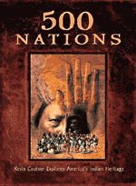
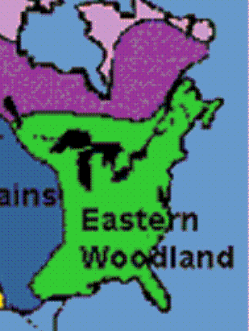

i. This culture consisted of Native American tribes inhabiting (living in) the _____________ United States and ____________. The Eastern Woodland Natives lived in a __________________ region ranging from the Atlantic to the Mississippi River including the Great Lakes. This area boasted ample __________, numerous lakes and rivers, and great __________________.
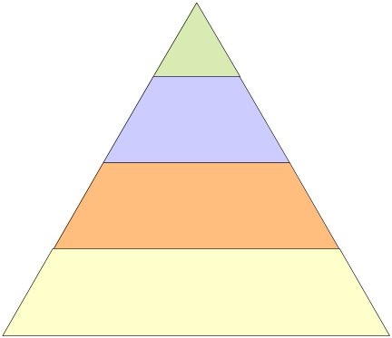
ii. The Eastern Woodland tribes lived in similar ways. Their ____________ societies were typically divided into ______________, including a chief, his children, the ________________ and commoners. Because of variations in climate and harvestable flora and fauna (plants and animals), tribes varied in ___________, housing, __________________ and ________________________.
Use the triangle to graph Eastern Woodland Culture

Eastern Woodland
i. Generally, the Natives were __________________________ and farmers. The men made bows and arrows, _________________ and war clubs. The women tended ___________ plots where beans, corn, pumpkin, _______________ and ________________were cultivated. The tribes lived near water for _______________________ purposes. The most popular homes were the _________________, a bark-covered structure, and the longhouse, home to several families.
ii. This group was the ___________ to come into contact with the ________________ that settled along the _________________ coast. They also taught the English settlers how to _____________maize corn, a crop that was ______________ to the Settlers’ _____________ in the first few years of settlement. Included in this group are the Algonquin (Powhatan Confederacy that helped the colonists at Jamestown) & the Wampanoag (Massasoit, Squanto, & Weetamoo & King Phillip that helped then fight the colonists at Plymouth & Massachusetts Bay) and the Mohican, Iroquois & the Cherokee.

Eastern Woodland: The Iroquois League
- The Iroquois League was a confederation (several tribes ____________ together) of six Native American _______________ in the ____________________United States. Mainly located in the _____________________ region. Originally occupying only Northern New York, the League would ______________ by alliance and conquest to control an area from Southern ______________ to ______________, and Eastern ________________________ to __________.
- The League was _____________ because it was ________________ and better defined than any other Native American _________________. It was based on a _____________ which _______________ the methods for choosing leaders and conducting business.
- The constitution included a decision-making ______________________ (much like Congress does today). It stressed _______________, ritual, and structure over individual leadership. It included _______________ for tribes to______ or ________ the Confederation.

Additional Notes on the Eastern Woodland Indians
_______________________________________________________________________________________________________________________________________________________________________________________________________________________________________________________________________________________________________________________________________________________________________________________________________________________________________________________________________________________________________________________________________________________________________________________________________________________________________________________________________________________________________________________________________________________________________________________________________________________________________________________________________________________________________________________________________________________________________________________________________________________________________________

What is one fact you found interesting about Eastern Woodland Natives? Why? Explain your answer.
________________________________________________________________________________________________________________________________________________________________________________________________________________________________________________________________________________________________________________________

Early Plains Culture (Pre-Columbian): Mound Builders
Watch the 6 minute clip from 500 Nations, Episode 1, Chapter 10 & 11 “Cahokia & the Great Sun” & “Other Mound Builders” When finished answer the following question in your listening guide:

What was the world of the Mound Builders like? Explain. What happened to the world of the Mound Builders? Explain.

Plains Culture (Post-Columbian): Textbook Readings 1

Read “The Great Plains” page 14 and Daily Life on page 15, pay particular attention to the painting. When completed answer the following question:

What are three ways the Plains Indian depended on the Buffalo?

1.

2.

3.



Plains: The People of the Horse
- Plains culture is the most recent Native American culture. The Great Plains people were __________________ from other Native American Nation because their _____________ radically changed following __________________ with Europeans. In fact the majority of the Plains peoples were not native to the Plains at all. Many of these tribal groups were native to the Eastern Woodlands. They were ________________onto the Plains when their lands were taken by European Colonists.

- The ______________ was introduced into this region by the Spanish in the 1600s. Many tribes traded goods for this ____________ and _____________ creature, which freed them from the immediate area surrounding their villages when they searched for game — especially the bison. They became _______________ hunters in long-distance _______________ of the thunderous, roaming bison.
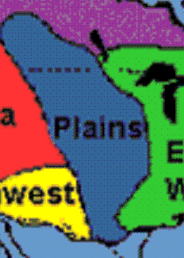
Plains
i. Lying east of the _____________________, and west of the Mississippi River the Great Plains consists of sprawling expanses of ___________________ up to 400 miles wide. The climate of the Great Plains grasslands is semiarid. Winters are cold and dry, and summers are warm to hot. These grasses made ideal ______________ for the _________________ (buffalo), which ______________________the lives of the Plains tribes.


ii. Given the _____________ lifestyle of many Plains tribes, the ______________ tipi was the dwelling of choice. These structures consisted of a _________________ pole frame covered with _________________. Included in this cultural group are the Sioux, the Ute, the Shoshone, the Crow, the Cheyenne and the Bannock.
Plains
Watch the 3 minute clip from 500 Nations, Episode 7, Chapter 8 “Horse Cultures” When finished answer the following question in your listening guide:

How did the horse change the life of Plains Indians? Explain.

Additional Notes on Plains Indians
____________________________________________________________________________________________________________________________________________________________________________________________________________________________________________________________________________________________________________________________________________________________________________________________________________________________________________________________________________________________________________________________________________________________________________________________________________

What is one fact you found interesting about Plains Natives? Why? Explain your answer.
________________________________________________________________________________________________________________________________________________________________________________________________________________________________________________________________________________________________________________________

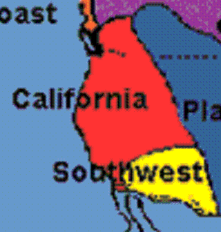
California
i. The California region boasts a wide variety of _________________ and geographical features. Nearly all California Native Americans lived along the __________________. They hunted __________and sea mammals by boat making it possible to get _______________.
ii. California Natives lived in ____________________ numbering up to 2,000 with homes. A house consisted of a _____________ frame covered with ___________. There was a skylight in the roof and the beds were made on _________________ frames—each with a partition for privacy. In the center of the floor, they made a __________________ for seeds, nuts, fish and other foods.
iii. More than __________ languages flourished in California; most languages are _________today. Included in this cultural group are the Athapascan, the Paiute and the Goshute.
California Indians Post U.S. History
i. Over 150,000 Native Americans lived in California prior to the Gold Rush (1849). They had existed for many centuries supporting themselves mostly by hunting, gathering and fishing. Over ______________ of these indigenous people _________ from disease first introduced by the “missions” and later by the gold miners. Another ______________ were ____________ into _______________ and/or massacred.
ii. These massacres had a devastating impact on indigenous (native) communities by quickly _______________ entire _______________ and _________________ groups. Deliberate massacres, slavery, racism, a system of reservations that starved people to death, and the mission system made survival of the first peoples of California almost impossible. That any survived is a testimony to their _____________ and __________ as peoples.
California: Chumash Culture & The Spanish Influence on Native Cultures
Watch the 6 minute clip from 500 Nations, Episode 7, Chapter 3 & 4 “The Chumash Culture” & “Missions: Conversion by force” When finished answer the following question in your listening guide:

What were two characteristics of life within the Chumash Nation? How did their culture change with the coming of “Missions”? Explain.
1.

2.

Additional Notes on California Indians
_______________________________________________________________________________________________________________________________________________________________________________________________________________________________________________________________________________________________________________________________________________________________________________________________________________________________________________________________________________________________________________________________________________________________________________________________________________________________________________________________________________________________________________________________________________________________________________________________________________________________________________________________________________________________________________________________________________________________________________________________________________________________________________

What is one fact you found interesting about California Natives? Why? Explain your answer.
________________________________________________________________________________________________________________________________________________________________________________________________________________________________________________________________________________________________________________________

Northwest Coastal
i. Native Americans of the Pacific Northwest inhabited the narrow __________________ stretching from Alaska to Northern Washington. Extensive mountain ranges isolated them from the rest of the country. There are a wide variety of climates. Oceanic climate (__________________ climates) dominated typically between the ocean and high mountain ranges where most Natives lived.

ii. Northwest Native Americans were generally __________________, though __________ between villages were common. The Northwest economy was based on ______________ natural resources, especially fish and _____________. Their diet consisted of red meat, fish, dried fruit and berries.
Northwest Coastal Culture
i. With plenty of food and building materials, Northwest Coastal Natives prospered. Individuals showed their wealth and earned social standing by holding special events called _________________. At these gathering hosts _________________ many belongings in order to gain respect.
ii. They also carved images of _________________, ancestors or animal _____________ on tall wooden poles. The stories of the totems were often told at potlatches.
Northwest Coastal Tribal Groups
i. Included in this cultural group are the Alaskan Tlingit, the Tsimshian, the Coeur d'Alene, the Lushootseed, the Makah, and the Nez Perce. They lived in ________________ much like those of the Eastern Woodland.
Additional Notes on the Northwest Indians
_______________________________________________________________________________________________________________________________________________________________________________________________________________________________________________________________________________________________________________________________________________________________________________________________________________________________________________________________________________________________________________________________________________________________________________________________________________________________________________________________________________________________________________________________________________________________________________________________________________________________________________________________________________________________________________________________________________________________________________________________________________________________________________

What is one fact you found interesting about Northwest Coastal? Why? Explain your answer.
________________________________________________________________________________________________________________________________________________________________________________________________________________________________________________________________________________________________________________________

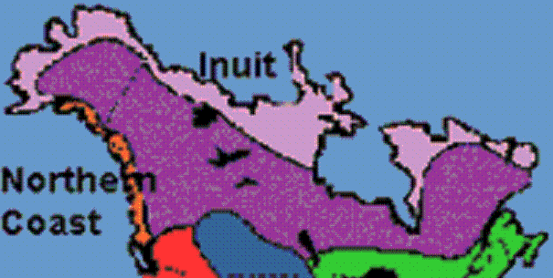
Inuit Indians Geography
i. Arctic tribes learned to __________ to one
of the harshest _______________on Earth.
ii. Traditionally, the Inuit people ___________ caribou, musk-ox, polar bear, seal, walrus and whales, and ______________ for Arctic char, cod and salmon. They ________________ berries and other vegetation during the short summer season. Traditional trade and bartering could span __________________.

Inuit Indians Culture
i. People lived in houses made of ________ and _____________________ with walrus skins for the roof and sides. The inside was lighted with bowl-shaped lamps, fashioned from clay or carved stone, fueled by ___________________. Cultural groups include the Inupiaq and the Yupik.
ii. When traveling throughout the region for hunting or trading, the Inuit built ______________ homes made of blocks of snow or ice commonly known as _________.
Additional Notes on the Inuit Indians
_______________________________________________________________________________________________________________________________________________________________________________________________________________________________________________________________________________________________________________________________________________________________________________________________________________________________________________________________________________________________________________________________________________________________________________________________________________________________________________________________________________________________________________________________________________________________________________________________________________________________________________________________________________________________________________________________________________________________________________________________________________________________________________

What is one fact you found interesting about Inuit Natives? Why? Explain your answer.
________________________________________________________________________________________________________________________________________________________________________________________________________________________________________________________________________________________________________________________

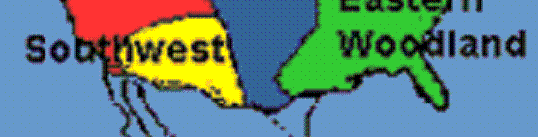
Southwest Geography
i. The Southwest's climate is generally _____________. Much of the land is ______________ dotted with cacti and other water-miser plants. A few green river valleys grace the land; summer rains in some areas allowed farming by peoples of remote times.
ii. Due to the _____________ size and varying geography of the region, the tribes of this region had several __________________ as well as differences. All tribes of this region were based on a __________________ supplemented by hunting and gathering. Because they were farmers and stayed in the same place year round, most tribes were not _____________. Tribal groups include the Anasazi, the Hopi, the Navajo and the Apache.
Southwest Culture
i. These tribes differed in the ___________ they farmed, the style of housing from _________ to mud (___________), grass huts, and occasional __________ for those that had to travel throughout the region to sustain themselves (_____________ Warriors).
ii. This group was the __________ to come into prolonged contact with the ___________________ (Spanish) coming up from __________________ and ______________ as early as 1541 AD. The Natives taught the Europeans how to grow __________, and beans these were ____________________ of food.
Southwest Film Clip
Watch the 10 minute clip from 500 Nations, Episode 1 Chapter 6,7 & 8 “The Anasazi” & “Chaco Canyon; Pueblo Bonito” & Cliff Palaces When finished answer the following question in your listening guide:

What are three traits and or traditions of the pre-Colombian Indians of the Southwest? Explain
1.
2.
3.

Additional Notes on the Southwest Indians
____________________________________________________________________________________________________________________________________________________________________________________________________________________________________________________________________________________________________________________________________________________________________________________________________________________________________________________________________________________________________________________________________________________________________________________________________________
What is one fact you found interesting about Southwest Natives? Why? Explain your answer.
________________________________________________________________________________________________________________________________________________________________________________________________________________________________________________________________________________________________________________________
Textbook Readings 2

Read Pages 10 to the top of page 14, pay particular attention to the pictures and maps. When finished answer the following questions:

1. How might the geography and climate of an area influence the culture that develops there?

2. How did the Native Americans of the Far North get their food?

3. How did the environment influence the food sources for Native Americans in the California and Northwest Coast regions?

4. How did Native Americans adapt to the dry environment of the West and Southwest?

Textbook Reading 3
Read pages 14 and 16 in the Call to Freedom textbook, when finished answer the following question:
- List at least three similarities and three differences between the cultures of Native Americans in the Great Plains and in the East:

SIMILARITIES | DIFFERENCES
1. | 1.
2. | 2.
3. | 3.

Notes:
____________________________________________________________________________________________________________________________________________________________________________________________________________________________________________________________________________________________________________________________________________________________________________________________________________________________________________________________________________________________________________________________________________________________________________________________________________________________________________________________________________________________________________________________________________________________________________________

Native Cultures Comparison Chart: Complete the following comparison chart for each of the Native American Cultural Groups.
Native American Cultural Group | Where were they located? (geography) | What was the climate/ Environment like? | Who were some of the tribal groups in this culture? | Culture: Homes & Clothing | Culture: Diet | Interesting Facts
Eastern Woodland

Plains

California (West)

Northwest Coastal

Inuit

Southwest

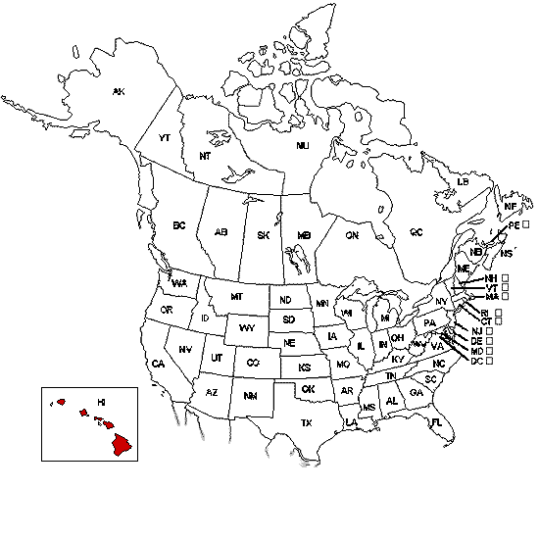
Native American Mapping Activity: On the following map, draw a circle around each region in which each Native American Cultural group lived. Label each region and draw a line to one of the boxes below. Label each box and draw a picture symbolizing each culture (for example their housing, diet, clothing etc…)



WalkAway Preparation
This required homework assignment is designed to help you prepare for the WALKAWAY exam on Native Americans . The homework consists of three steps. Step 1: Review. Step 2: Complete Practice online exam on UCUTIPS. Step 3: Gather Parent Signature. This assignment must be completed prior to the exam!
Step 1: Review (1) Read your listening guide Unit II Introduction to Native Americans. (2) While reading, pay attention to the blanks, make sure you know and understand the information.
Step 2: Complete Practice online exam.
1. Go to: http://www.ucutips.org/~willowhistory/
2. Access the Native American Practice Exam from the left hand tool bar, under: “Practice WalkAway Exams Folder” .
3. Open the Native American Practice exam.
4. Use the drop down menus to access the test.
A. Follow the format below.
B. Under the Teacher drop down menu, find your teacher’s name.
C. Under the Class drop down menu find your class number
D. Under the Name drop down menu, find your name, login and start.
E. While taking the practice exam write down the questions and answers YOU MISS (write the entire question not the number).
Top of Form
Native Americans Practice Walkaway | 
Open Book TestID: 201066
30 Question(s)
30 - Forced Response

District:
School:
Teacher: | Elizabeth Robertson
Class:
Name:


If you are unable to do a detailed login, do a simple login.

Step 3 Gather Parent Signature: Show your parents your written notes from the practice exam. Review these notes with your parents. If necessary have them quiz you about the information with which you need additional help. Have them sign below once completed

Student name: _____________________________________
*Parent name: ______________________________________
*We appreciate your involvement in your child’s learning. We are aware some students do not have access to the internet. Please note the test is available anywhere students can access the internet, i.e. the school and public library, as well as in our classroom Wednesdays and Thursdays after school.

BELOW, write down all of the questions you missed with the full, detailed answers. You may use an additional sheet of paper if needed.

Summary of Question | Complete CORRECT ANSWER

Appendix Native Americans
Primary Documents
Speech by Powhatan, as recorded by John Smith, 1609

Why will you take by force what you may obtain by love? Why will you destroy us who supply you with food? What can you get by war? . . . We are unarmed, and willing to give you what you ask, if you come in a friendly manner. . . .

I am not so simple as not to know it is better to eat good meat, sleep comfortably, live quietly with my women and children, laugh and be merry with the English, and being their friend, trade for their copper and hatchets, than to run away from them. . . .

Take away your guns and swords, the cause of all our jealousy, or you may die in the same manner.

Source: Smithsonian Teacher Sources

A Huron Indian to Jesuit missionary Jean de Brébeuf, 1635
During the 1600s and 1700s Jesuit missionaries traveled to America in an effort to convert Native Americans to Christianity. Although some were successful, others, as this document demonstrates, were not able to supercede Native American religious practices.

You tell us fine stories, and there is nothing in what you say that may not be true; but that is good for you who come across the seas. Do you not see that, as we inhabit a world so different from yours, there must be another heaven for us, and another road to reach it?

Source: A Huron Indian to Jesuit missionary Jean de Brébeuf, 1635 as cited in the Smithsonian Teacher Sources

Dutch missionary John Megapolensis on the Mohawks (Iroquois), 1644
In 1643, Dutch minister John Megapolensis became the town’s first pastor at Fort Orange (near Albany). As pastor he was not allowed to farm or trade, but received support from the town, while diligently performing his duties, which included teaching the Indians about Christ.

The Women are obliged to prepare the Land, to mow, to plant, and do every Thing; the Men do nothing except hunting, fishing, and going to War against their Enemies: they treat their Enemies with great Cruelty in Time of War, for they first bite off the Nails of the Fingers of their Captives, and cut off some joints, and sometimes the whole of the Fingers; after that the Captives are obliged to sing and dance before them . . ., and finally they roast them before a slow Fire for some Days, and eat them. . . . Though they are very cruel to their Enemies, they are very friendly to us: we are under no Apprehensions from them. . . .

They are entire Strangers to all Religion, but they have a Tharonhijouaagon, (which others also call Athzoockkuatoriaho) i.e. a Genius which they put in the Place of God, but they do not worship or present Offerings to him: they worship and present Offerings to the Devil whom they call Otskon or Airekuoni. . . . They have otherwise no Religion: when we pray they laugh at us; some of them despise it entirely, and some when we tell them what we do when we pray, stand astonished. When we have a Sermon, sometimes ten or twelve of them, more or less, will attend, each having a long Tobacco Pipe, made by himself, in his Month, and will stand a while and look, and afterwards ask me what I was doing and what I wanted, that I stood there alone and made so many Words, and none of the rest might speak? I tell them I admonished the Christians, that they must not steal, . . . get drunk, or commit Murder, and that they too ought not to do these Things, and that I intend after a while to preach to them. . . . They say I do well in teaching the Christians, but immediately add Diatennon jawij Assyreoni hagiouisk, that is, why do so many Christians do these Things. They call us Assyreoni, that is, Cloth-Makers, or Charistooni, that is, Iron-Workers, because our People first brought Cloth and Iron among them...

Source: Ebenezer Hazard, Historical Collections (Philadelphia, 1792), 1, 520-526.

Name_____________________________________
Period_____________
Native American Alternative Assessment—Display/Storyboard

You have been hired for the National Museum of the American Indian Smithsonian. You have been asked to construct a storyboard for the display of Native Americans. You must identify the geographic regions of all seven cultural groups, and identify the food, shelter, clothing, and beliefs of five of the seven cultural groups of Native Americans.

Seven cultural groups: Southwest, West, Northeast Coast, Southeast, Great Plains, Pacific Northwest, Mesoamerica.

Geography
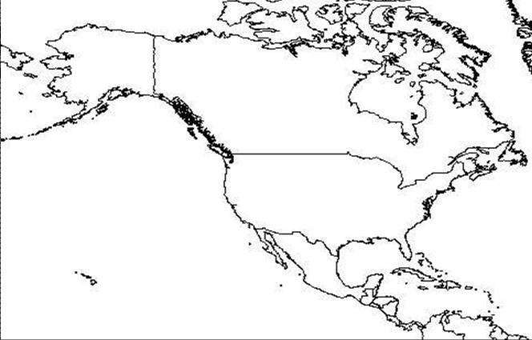
Outline the area where the seven culture groups lived. Label mountains, rivers, and plains that are included in that area, or that separate the areas from each other.

Food  List five of the seven cultural groups and draw the food(s) for each. | C. ________________________________________ (group)
A _______________________________________ (group) | D. _________________________________________ (group)
B ________________________________________ (group) | E. ________________________________________ (group)

Shelters  List five of the seven cultural groups and draw a shelter for each. | C________________________________________ (group)
A________________________________________ (group) | D________________________________________ (group)
B________________________________________ (group) | E________________________________________ (group)

Clothing  List five of the seven cultural groups and draw an article of clothing for each. | C________________________________________ (group)
A________________________________________ (group) | D________________________________________ (group)
B________________________________________ (group) | E________________________________________ (group)

Beliefs  List five of the seven cultural groups and draw a picture that represents a belief (religion, myth, tradition, legend) for each. | C________________________________________ (group)
A________________________________________ (group) | D________________________________________ (group)
B________________________________________ (group) | E________________________________________ (group)
Timeline
List five events that happened to the Native Americans before and after Columbus and explain why these events were important.

Pre-Colombian events

1. ______________________________________________________________________________________________________________

2. ______________________________________________________________________________________________________________

3. ______________________________________________________________________________________________________________

4. ______________________________________________________________________________________________________________

5. ______________________________________________________________________________________________________________

Post-Colombian events

1. ______________________________________________________________________________________________________________

2. ______________________________________________________________________________________________________________

3. ______________________________________________________________________________________________________________

4. ______________________________________________________________________________________________________________

5. ______________________________________________________________________________________________________________
List three specific tribes in each cultural area

Southwest

1. __________________________________________

2. __________________________________________

3. __________________________________________
West

1. __________________________________________

2. __________________________________________

3. __________________________________________
Northeast Coast

1. __________________________________________

2. __________________________________________

3. __________________________________________
Southeast

1. __________________________________________

2. __________________________________________

3. __________________________________________

Great Plains

1. __________________________________________

2. __________________________________________

3. __________________________________________
Pacific Northwest

1. __________________________________________

2. __________________________________________

3. __________________________________________
Mesoamerica

1. __________________________________________

2. __________________________________________

3. __________________________________________

NOW . . . EXPLAIN what you have drawn in each of the display areas of the storyboard. Identify the item explain what cultural area it belongs to, and explain why it was what was unique in that specific cultural area.

Geographic Area | Cultural group of the Geographic Area | Natural Resources of the  Geographic Area
A

B

C

D

E

Food | Cultural group that ate the food | How geography affected the food supply and availability geographic region
A

B

C

D

E

Shelter | Cultural group that used the shelter | What the shelter was made from and why those specific materials were used in that geographic region
A

B

C

D

E

Clothing | Cultural group that wore the clothing | What materials the clothing was made from and why those specific materials were used in that geographic region
A

B

C

D

E

Beliefs | Cultural group identified with the specific belief | Identify what the belief was and why it was held within that geographic region
A

B

Beliefs (cont….)
C

D

E

