Polygamy & Utah’s Struggle for Statehood
Objective: Students will understand the problems facing Utah in the late 19th century and the process (and eventual success) of Utah’s struggle for statehood.

- Why would Utah want to become a state?
- Rights ____ __________________
- __________________ in the government
- Elect their ______ _______________
- Pay taxes
- Receive government _________________
- _______________ of citizenship

What Problems got in the way of Utah’s Statehood?
- POLYGAMY
- Size and borders of the territory
- Tensions with Native Americans
- Church and State
- Slavery (prior to the Civil War)
- Tensions with the U.S. Government- Rebellion & Military issues
- Political Parties

- If you had to draw the boundaries for your own state, what would you make sure was inside of it? Brainstorm and think of the vital resources & geographical features you would want to make sure were part of your state.
- ___________________________
- ___________________________
- ___________________________

- What does Deseret mean? ______________________

- Why did Brigham Young propose the state of Deseret? What reasoning was there behind it?

- Native Americans- Look at the picture on page 127 in your Utah history textbook
-Who are the different people in the cartoon?

-What is the cartoonist trying to say about each group?

-Why would this be a problem for Utah's pending statehood?

- List 5 qualities you think every good American should have. Discuss with your partner and come up with your top 3 qualities.

- POLYGAMY
Definition of polygamy: the practice of having __________________ wife at a time.
The Mormon church publicly announced the doctrine of plural marriage in August _______.

7. The Mormons defended that their reason for practicing plural marriage included:
- God had commanded the reestablishment of the sacred practices of the Israelite patriarchs and kings
- _________________ of the Earth
- A commandment from _______

- How many practice polygamy?
- Mormons claimed only a small number of men were polygamous in the 1880’s.
  - Mormons insisted that only about ______ percent were polygamous.
- Other evidence shows most likely about _________percent were
- Marriage numbers did recede during the 1870-1880’s, because of governmental__________

- How did the Edmunds-Tucker Act affect Utah?
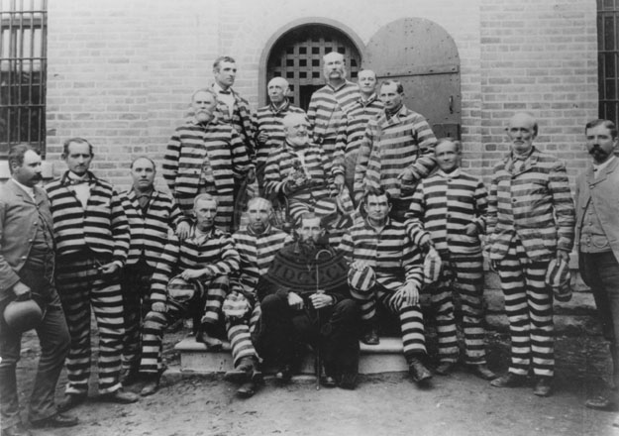

- If someone was caught the punishment could be the following:
  - ______ years in prison
  - $______ Fine
  - Over _________ polygamists were put in prison.

- Stereotypes:
- Throughout the United States polygamy was viewed as __________ (people thought everyone in Utah was doing it)
- People heard of men having _________ wives and that wives were forced to be ________ to the men.
- People began to feel _________ and disdain towards members & Utahns.
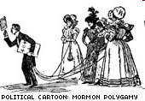

- Journal Write: Would you be willing to share your spouse, or take a second, third, etc… Spouse? What might be some of the advantages and disadvantages? Under what circumstances, if any, would you be willing to practice polygamy? Explain. (Fill the entire space)

Watch the video: Utah’s Struggle for Statehood & Answer the below questions: #13-26
- Who was John Taylor?

- How was polygamy looked upon outside of Utah?

- Why did John Taylor not obey the polygamy laws?

- What was the Hole in the Rock?

- What was the court case of Reynolds vs. the United States?

- How were the Mormon’s treated after the Supreme Court decision?

- What was the nation’s biggest social problem? ____________________________

- Why did the prison population grow so much?

- How were children harassed by the federal government?

- What was the underground?

- Where and why did some Mormons start leaving Utah?

- What happened on July 4th 1875?

- What did the Edmunds Tucker act do? Why was it enacted?

- How did the Mormon’s get public opinion changed towards the church?

- Tensions with the U.S. Government
- “Utah War”-series of armed confrontations between Utahns & the Federal Government from May _______ to July ______.
  - Not a true “war.” There were no official ____________.
  - President Buchanan heard rumors of a supposed “__________” in Utah, sent Colonel _____________ Army to put an end to it.
  - War was ___________. Tensions eventually died down.
- Mountain Meadow’s Massacre- September ________
- Due to massive war hysteria & fear of outsiders, Utahns attack and kill ______ people in a wagon train headed West.

- Joined National Parties
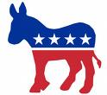
- In the Utah territory most Mormons voted the same. Why would they vote the same?

- Many Mormons lost the __________ because of Federal laws against polygamists.
- In order to fall in line with the rest of the nation the LDS church ____________ it’s members to join one of the ___________________.
- 1892: _______ two party elections held in Utah
- _________ : Bill written to admit Utah into the Union passes in Congress

- Manifesto
Statement made by the Mormon 1st presidency and quorum of the twelve in_______ , ending any _____ polygamous marriages.

I publicly declare that my advice to the Latter-day Saints is to refrain from contracting any marriages forbidden by the law of the land.
-Wilford Woodruff, President of The Church
of Jesus Christ of Latter-day Saints

- Apply Again!
- _________ - Delegates attend Utah Constitutional Convention
- The new constitution was put up for a vote and was accepted in a vote of 31,305 to 7,687.

- Author’s of Utah’s Constitution:
Party | Age | Occupation | Birthplace | Religion
59 Republicans  48  Democrats | 24-76 | 28 Farmers & Ranchers  15 Lawyers  13 Merchants  8 Mining Businessmen  6 Educators  5 Churchmen  4 Newspapermen  3 Bankers  3 Builders  Others, including a Photographer, a blacksmith, a clerk, a mason, a brewer and a druggist. | 47 Other Territories or States  37 Foreign Countries  28 Utah Territory | 79 Mormons  2 Catholics  1 Episcopal Minister  1 Jew  1 Methodist
Draw some conclusions. Identify what were some of the prominent jobs of those who wrote the Constitution.? What does that say about the values of Utah?

Struggle for Statehood Timeline

Utah first applies for _______________________________. It is denied.

_________

U.S. Congress establishes Utah _____________________. Brigham Young is appointed the first __________________________.

_________

The L.D.S. Church officially announces the practice of _________________, when one man is married to multiple women. __________________________.

1852

“___________________________” begins. Johnston’s federal ______________ are sent from the east. Mountain ___________________ massacre.

_________

Outbreak of the ____________________ in the South. Johnston’s army leaves ________________.

_________

Utah’s ___________________ gain ____________________ (the right to vote). In 1887 it is taken away until the 19th amendment allows all women to vote.

1869

Edmunds Act passes in ________________________. Polygamist arrests intensify and many husbands go into hiding.

_________

The ________________________, issued by Wilford Woodruff (President of the L.D.S. Church), ended the practice of plural marriage.

_________

Utah becomes the _______th state!
1896

