Transcontinental Railroad
Students will evaluate what life was like in the Utah Territory and understand keys aspects of the Pony Express, Telegraph, and the Railroad.

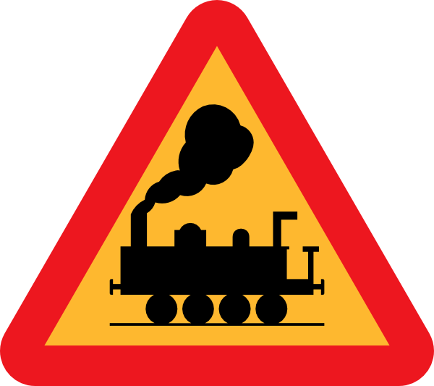
- Trains first started in: ________ by John Blenkinsop. He designed the first successful and practical locomotive in ____________.

- Railroad era in the United States started in _________ when the first USA train, “________________ ”went from Baltimore to Ohio.

- 1862: President Abraham Lincoln signed the ____________________which authorized the construction of the first transcontinental railroad.

- Transcontinental:__________________________________________________________

- Construction took 6 years: from ___________________

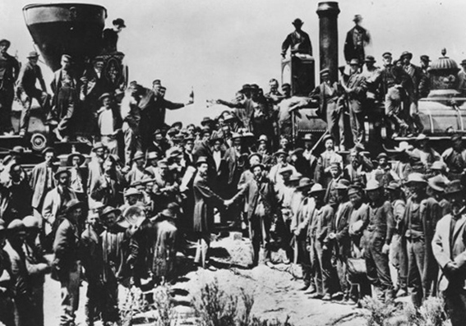
- Two companies contracted to build the railroad: ___________________ Railroad & ___________________Railroad

- Union Pacific started in Omaha, _______________. Central Pacific started in _________________, California.

- ___________________: Transcontinental Railroad joins in Utah at ______________________________________

- How did the Railroad impact Utah? (3 ways)
  - ______________________________________________________________________
  - ______________________________________________________________________
  - ______________________________________________________________________

“Coolies” by Yin Chris Soentpiet
- What it was like to be a railroad worker:

- What discrimination did Chinese workers face?

Pretend you are a journalist for the Deseret News in 1869. Write a headline and article (7 sentences) about the transcontinental railroad and the exciting Golden Spike Ceremony connecting the East & West here in Utah. Mention at least one impact of the railroad on Utah in your article. Be creative and use your best penmanship.

