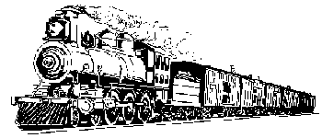
Homework: Railroad Timeline

Using your Utah History Textbook and/or the Internet create Railroad Timeline.
DUE: Thursday, November 29th

Your Timeline must include:
- 5 dates with descriptions
- 2 pictures (either drawn neatly with color or clip art)
- 3 sentences about how the construction of the railroad influenced Utah.

The Timeline must be:
- Professional
- Neat
- Organized

This timeline is worth 25 points

Recommendation: Use a blank white sheet of computer/copy paper and a ruler, black ink, etc… to make everything look neat and detailed.

*Alternate option: Timeline can be about polygamy in Utah instead of the railroad.

Homework: Railroad Timeline

Using your Utah History Textbook and/or the Internet create Railroad Timeline.
DUE: Thursday, November 29th

Your Timeline must include:
- 5 dates with descriptions
- 2 pictures (either drawn neatly with color or clip art)
- 3 sentences about how the construction of the railroad influenced Utah.

The Timeline must be:
- Professional
- Neat
- Organized

This timeline is worth 25 points

Recommendation: Use a blank white sheet of computer/copy paper and a ruler, black ink, etc… to make everything look neat and detailed.

*Alternate option: Timeline can be about polygamy in Utah instead of the railroad.

