Unit IV: The Middle Ages to the Spanish in the Americas
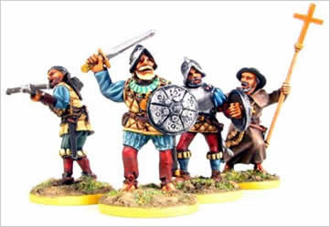

Instructions for completing the Unit IV Middle Ages to the Spanish in America Listening Guide.
Listen to the lecture in class, while doing so complete the underlined blanks in your listening guide. In the accompanying slideshow presentation the blanks with the correct words or concepts are completed and underlined for emphasis. There are a series of learning activities in the listening guide including: journal writes, geography links, reflection questions, textbook activities, homework and movie clips that accompany this listening guide. You should also take notes in the margins or in the note paper available at the end of the listening guide of additional information presented by the instructor during the lecture. Make sure that you bring the listening guide with you to class daily. If you are absent from class it is your responsibility to get the information by listening to the online podcast, available from a link on the class website. Listening guides must be completed prior to taking a WalkAway.

Enduring Understanding: Students will recognize the role religion played in the development of American History
Essential Questions:
1. What role did Catholicism, Judaism and Islam play in Africa, Asia and Europe during the middle ages?
2. How were religious conflict and trade intertwined during this period and how did they encourage the discovery of the Americas?
3. What role did Spanish Catholicism play in the conquest of the Americas?
4. Who, how, when, where, and why were the early Explorers and Conquistadores. What were their motives?
5. What impact did colonization have on the Native populations of the Caribbean and South America?
6. Compare and contrast the positive and negative consequences of the Columbian Exchange?

Europe to America
  - In 1492 Columbus “bumped” into the Americas.
  - During the 15th & 16th centuries Spain successfully colonized Central America, Mexico, and most of South America. In doing so, they transplanted their culture to the Native Peoples.
  - Both England and France built colonies in North America. Within a century, their countries and colonies were devastated by Religious Wars.
  - The single most powerful _____________ in Europe during the 15th, 16th and 17th centuries was _____________.
Assessment
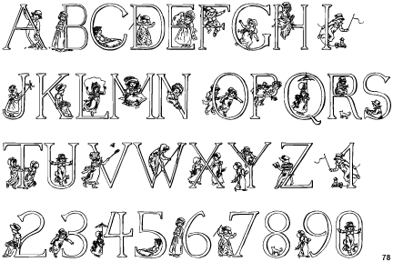
- At the end of this unit, you should be prepared to answer the Reaction Response questions available within the Spanish in America online exam and in the listening guide (The response should be at least one page typed, double spaced).

1) It has been said that the Spanish conquered the Americas to get GOLD, share GOD, and receive GLORY. Give specific examples of individuals, ideas and/ or events that support each of these motives.

- There will be a UCUTIPS exam covering The Spanish in America. Currently posted online.

Textbook Assignment Pages 17-22 “Call to Freedom” textbook. Reading Checks.

1. How did daily life differ for nobles and peasants during the Middle Ages?

2. What role did the Catholic Church play in people’s lives during the Middle Ages?

3. How did countries change in the late Middle Ages?

Textbook Assignment Pages 17-22 “Call to Freedom” textbook. Multiple Choice.

A. During the Middle Ages, Europeans were identified by their wealth and power. Number the following classes from 1, for the richest and most powerful, to 6, for the poorest and least powerful:
______serfs ______slaves ______free tenants
______kings ______vassals ______nobles
B. During the Middle Ages, the religion practiced by most Europeans was called:
a. Christianity b. feudalism
c. nobility d. Magna Carta
C. Monks lived in religious communities called:
a. manors b. monasteries
c. convents d. estates
D. During the late Middle Ages, kings gained control of larger areas and reduced the power of:
a. priests b. monks
c. peasants d. nobles
E. King John of England was forced to uphold the rights of nobles after he signed
a. Magna Carta b. The Domesday Book
c. Rules for Monks d. Declaration
F. Toward the end of the Middle Ages, towns began to grow as a result of:
a. The spread of trade b. lower levels of food production
c. Smaller population d. traditional farming methods
Christianity and The Roman Empire
  - From appx. 200 BC to 400 AD, Rome had _____________ and ruled much of Western Europe, the Mediterranean, Northern Africa, and the Middle East.
  - In 313 AD, the _____________ was legally recognized by the Roman Emperor Constantine, and in 380 AD it became the _____________religion of the Roman Empire.
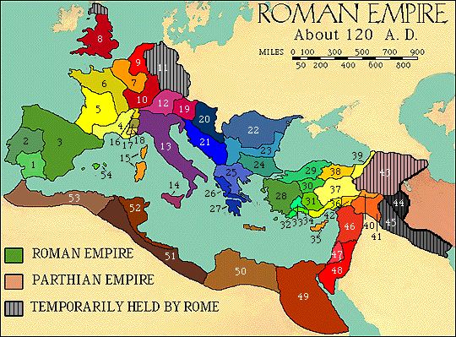

Fall of the Roman Empire
  - The remnants of the Roman Empire broke up into hundreds of _____________.
  - This period, from appx. 400 to 1400AD, is known as the _____________
Western Europe & The Middle Ages
  - Individual kingdoms were ruled by _____________, kings and queens. Their powers were weak, and often they fought with feudal lords for control of their kingdoms.
Western Europe & The Middle Ages
  - _____________was the _____________ church in Western _____________ during the Middle Ages, it had its own laws and income.
  - _____________ such as bishops and archbishops sat on the king's council and played leading roles in _____________
  - _____________ were often wealthy and came from noble families, and _____________over some _____________


What role did the Church play during the middle ages? Give an example. How is that role the same or different today? Explain.
__________________________________________________________________________________________________________________________________________________________________________________________________________________________________________________________________________________________________________________
Western Europe & The Middle Ages
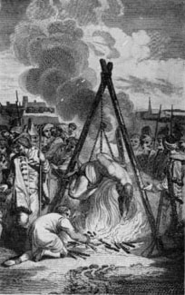
- _____________ were _____________whose beliefs did ____completely _____________ with the church of the Middle Ages (200-1400 AD)
- _____________were often referred to as _____________
- Including: _____________and many _____________Christian groups.
Western Europe & The Middle Ages
- Persecution of Heretics.
- _____________ at the _____________was a common way to persecute heretics.
Western Europe & The Middle Ages
- Hundreds of years later, in the 1690’s, this same practice occurred in the American Colonies. A series of “_____________” were held and over _______ colonists were convicted of practicing “_____________.” Nineteen were eventually hung as Witches.
The Middle East & North Africa during the Middle Ages
- The Fall of Rome left the _____________ and _____________ in shambles.
- Remnants of Christians, Jews, and “Pagans” were left in these areas; ___ single _____________was _____________.
The Middle East & Africa during the Middle Ages
- Aided by the lack of stability and _____________, _____________ quickly throughout much of the Southern & Eastern remnants of the _____________
The Middle East & Africa during the Middle Ages
- By the 1400's _____________ had grown to have the _____________ power and _____________ in the South as _____________ had in the North.
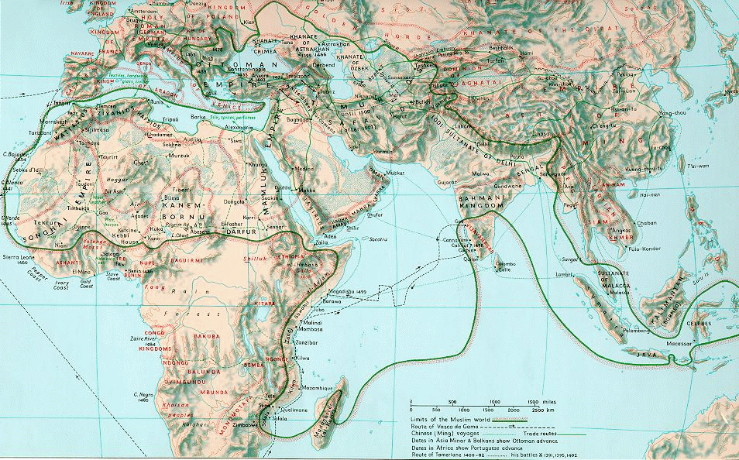
Map of the Islamic World AD 1500

Write down five adjectives that describe the Middle Ages. Try to include the Christian World, the Muslim World, and the Jewish World.
___________________________________________________________________________________________________________________________________________________________________________________________________________________________________________________________________________________________________________________________________________________________________________________________________

Three Worlds Clash: The Crusades
- The Crusades: 1095 AD
- _____________calls for the 1st of 9 _____________ to the Holy Land.
- The “purpose” of the Crusades was to_____________ from the non-believers i.e _____________ _____________.
Three Worlds Clash: The Crusades Christianity, Judaism & Islam meet
- People went on Crusades for various _____________
  - Genuine _____________
  - Promise of _____________
  - _____________ (i.e they stole cool stuff)
“Blood ran through the streets of Jerusalem like a river.” --St. Josephus

Short term Consequences of the Crusades
- In most cases the ___________ and resulted in many ___________ (The Children’s Crusade)

In one Children’s crusade, Nicholas, a shepherd boy from Germany had a vision that Jesus would lead them to peacefully free Jerusalem from the Muslims. He led a group of about 7,000 children across the Alps and into Italy; however, their plans didn't work, the sea did not part as promised and the band broke up. Some left for home, others were sold into slavery. Few returned home and none reached the Holy Land.

- Even when they succeeded in taking portions of Jerusalem, they were soon _____________ again, as the Crusaders returned to their homes.
- The _____________ were _____________ by the Pope to _____________ lands that were taken by the Crusaders (Warrior Priests).

Long term consequences of The Crusades
- _____________ and _____________among _____________and _____________
- As Crusaders brought home exotic spices, cloths and perfumes from the East, they exposed Europeans to __________. These goods increased the desire for _____________ to the East!

Long Term Consequences of the Crusades: -Search for new trade routes
- The _____________ linked _____________ to the _____________
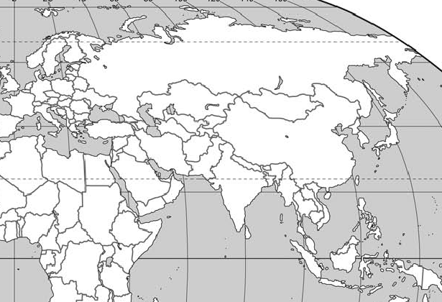
Using the instructional PowerPoint and the map provided below map the route of the silk road. Be sure to identify the primary bodies of water, and key political and physical features that were within the route.

The Silk Road traveled from the Middle East to Asia. Travelers crossed deserts, rivers, mountains and forests. They braved the terrain, the elements, and robbers.

- For many years Muslim traders had used the Silk Road to _____________ such as silks, spices, herbs and perfumes to the Middle East.
- The Silk Road was _____________ to ____________ due to the _____________ The lingering effects of the Crusades and ___________ in the region made it even more difficult.
- As a result _____________ began _____________ for alternate _____________

Long term consequences of The Crusades
- Some came to believe that the Crusades included re-taking any lands that had previously been ruled by Christians that had _____________to Muslim rulers.
- Spain had fallen to Muslim Invaders in 700 AD. Many _____________ to the Northern Mountains of Spain.
- Over a three hundred year period Christian Kings and Muslim Caliphs fought for control of Spain. In 1492 the Christian Monarchs, Ferdinand and Isabel, were successful in _________ Spain, and _____________ the _____________

Long term consequences of The Crusades
- In 1492 Ferdinand and Isabel returned Spain to _____________ rulers.
- In an effort to consolidate their power they began the ___________ (punishment of Heretics).
  - Non-believers were _____________ to convert or were punished or banished.
- In the centuries following Spain took on the role of _____________ (Catholicism). They instituted the Inquisition in all the lands they conquered, and _____________Catholicism throughout their _____________

Long term consequences of The Crusades
- Because of the Crusades and because Spain had expelled the Muslims with the Inquisitions, the _____________ became _____________ to travel.
- In 1492, Isabel hired Christopher _____________ to find an _____________ route to Asia (something other than the Silk Road).
- The alternate road he “discovered” led not to Asia but to the _____________

Think About It
Why do you think the Crusades were so important for Christians during this time? What did they hope to accomplish? Why was Jerusalem so important to them?
________________________________________________________________________________________________________________________________________________________________________________________________________________________________________________________________________________________________________________________

What impact do you think the Crusades have had on people today? What perceptions do you think Muslims must have of Christians? What about Jews?
________________________________________________________________________________________________________________________________________________________________________________________________________________________________________________________________________________________________________________________

In many ways the Americas were the last Crusade

Part I: Religion, the Crusades, Discovery of America
Main Idea | Details or Examples
Catholicism, Judaism and Islam played a major role in Africa, Asia and Europe during the Middle Ages. | 1.  2  3.  4.
The Crusades had short term consequences. | 1.  2.  3.  4
The Crusades had long term consequences. | 1  2  3  4
Both Religious conflict and trade led to the discovery of the Americas | 1  2  3  4

Enduring Understanding: Students will recognize the role religion played in the development of American History.
Essential Questions:
3. What role did Spanish Catholicism play in the conquest of the Americas?
4. Who, how, when, where, and why were the early Explorers and Conquistadores. What were their motives?


Journal Write
- If you had the opportunity to travel to a newly discovered land about which we knew very little, would you do so? Why? What would you want to do? See? Experience? What would you be afraid of? How do you think your life would change? How do you think the experience would change others? Explain your answer. (150 words)

________________________________________________________________________________________________________________________________________________________________________________________________________________________________________________________________________________________________________________________________________________________________________________________________________________________________________________________________________________________________________________________________________________________________________________________________________________________________________________________________________________________________________________________________________________________________________________________________________________________________________________________________________________________________________________________________________________________________________________________________________________________________________________________________________________________________________________________________________________________________________________________________________________________________________________________________________________________________________________________________________________________________________________________________________________________________________________________________________________________________________________________________________________________________________________________________________________________________________________________________________________________________________________________________________________________________________________________________________________________________________________________________________________________________________________________
Think about it…
Does might make right? Explain your answer in context of what happened in Spanish America. Be prepared to transfer your answer to a discussion of current events and issues.

The Diary of Christopher Columbus
Read the supplied diary of Christopher Columbus. In your listening guide answer the following three questions:
1) Who did Columbus expect to read his journal? How can you tell?

2) Why do you think Columbus told his crews that the fleet was covering less distance each day than it really was?

3) According to Columbus what were the native peoples encountered like? Based on his descriptions what do you think the Spanish intentions towards the natives were?
Columbus Discovers America
Christopher Columbus, an Italian navigator serving Spain, kept a detailed journal of his voyage to America. Although the original has been lost, many of the admiral’s descriptions became a part of an abridgement of the journal by Spanish historian Bartolome de las Casas
Wednesday, October 10th
He sailed west-southwest, at the rate of ten miles an hour and occasionally twelve, and at other times seven, running between day and night fifty-nine leagues [236 miles], he told the men only forty-four [176 miles]. Here the crew could stand it no longer, they complained of the long voyage, but the Admiral encouraged them as best he could, giving them hopes of the profits that they might have. And he added that it was useless to murmur because he had come to [in quest of] the Indies, and was going to continue until he found them with God’s help.
Thursday, October 11th
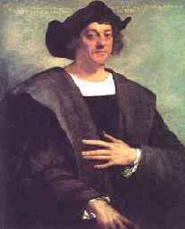
…Soon after a large crowd of natives congregated there. What follows are the Admiral’s own words in his book on the first voyage and discovery of these Indies. “In order to win the friendship and affection of that people, and because I was convinced that their conversion to our Holy Faith would be better promoted through love than through force; I presented some of them with red caps and some strings of glass beads which they placed around their necks, and with other trifles of insignificant worth that delighted them and by which we have got wonderful hold on their affections. They afterwards came to the boats of the vessels swimming, bringing us parrots, cotton thread in balls, and spears, and many other things, which they bartered for others, we gave them, as glass beads and little bells. Finally they received everything and gave whatever they had with good will. But I thought them to be a very poor people…I saw but one very young girl, all the rest being young men, none of them being over thirty years of age, their forms being very well proportioned, their bodies graceful and their features handsome: their hair is as coarse as the hair of a horse’s tail and cut short. They wear their hair over their eye brows except a little behind which they wear long, and which they never cut. Some of them paint themselves black, and they are of the color of the Canary Islanders, neither black nor white, and some paint themselves white, and some red, and some with whatever they find, and some paint their faces, and some the whole body, and some their eyes only, and some their noses only. They do not carry arms and have no knowledge of them, for when I showed them the swords they took them by the edge, and through ignorance, cut themselves. They have no iron, their spears consist of staffs without iron, some of them having a fish’s tooth at the end, and others other things. As a body they are of good size, good demeanor, and well formed, I saw some with scars on their bodies, and to my signs asking them what these meant, they answered in the same manner, that people from neighboring islands wanted to capture them, and they defended themselves, and I did believe and do believe, that they came from the mainland to take them prisoners. They must be good servants and very intelligent, because I see that they repeat very quickly what I told them, and it is my conviction that they would easily become Christians, for they seem not to have any sect. If it please our Lord, I will take six of them from here to your Highnesses on my departure, that they may learn to speak. I have seen here no beasts whatever, but parrots only.
Saturday, October 13th
… They brought balls of spun cotton, parrots, spears, and other little things which would be tedious to describe and gave them away for anything that was given to them. I examined them closely and tried to ascertain if there was any gold, and noticed that some carried a small piece of it hanging from a little hole in their nose, and by signs I was able to understand that by going to the south or going around the island to the southward, there was a king who had large gold vessels, and gold in abundance. I endeavored to persuade them to go there, and I afterwards saw that they had no wish to go. I determined to wait, until tomorrow evening, and then to sail for the southwest, for many of them told me that there was a land to the south and southwest and to the northwest, and that those from the northwest came frequently to fight with them, and so go to the southwest to get gold and precious stones.
Sunday, October 13th
…At dawn I ordered the boat of the ship and the boats of the Caravels to be got ready, and went along the island, in a north – northeasterly direction, to see the other side, which was on the other side of the east, and also to see the villages, and soon saw two or three and their inhabitants, coming to shore calling us and praising God, some brought us water, some eatables, others when they saw that I did not care to go on shore, plunged into the sea swimming and came, and we understood that they asked us if we had come down from heaven, and one old man got into the boat, while others in a loud voice called both men and women saying :come and see the men from heaven, bring them food and drink. A crowd of men and many women came, each bringing something, giving thanks to god, throwing themselves down, and lifting their hands to heaven, and entreating or beseeching us to land there… the people are totally unacquainted with arms, as your Highnesses will see by observing the seven [earlier indicated six] which I have caused to be taken in order to carry them to Castile to be taught our language, and to return them unless your Highnesses when they shall send orders may take them all to Castile, or keep them in the same island as captives, for with fifty men all can be kept in subjection, and made to do whatever you desire.”

Slide 24: Watch the film “500 Nations” the 20 minute clip, chapters 2-7 Columbus & the Taino. In your listening guide answer the following three questions:
1) How did the Taino Natives treat Columbus on his arrival in the Americas?

2) Why did the relationship between the Taino and the Spanish change?

3) What eventually happened to the Natives in the Caribbean following the arrival of the Spanish?

Notes

________________________________________________________________________________________________________________________________________________________________________________________________________________________________________________________________________________________________________________________________________________________________________________________________________________________________________________________________________________________________________________________________________________________________________________________________________________________________________________________________________________________________________________________________________________________________________________________________________________________________________________________________________________________________________________________________________________________________________________________________________________________________________________________________________________________________________________________________________________________________________________________________________________________________________________________________________________________________________________________________________________________________________________________________________________________________________________________________________________________________________________________________________________________________________________________________________________________________________________________________________________________________________________________________________________________________________________________________________________________________________________________________________________________________________________________________________________________________________________________________________________________________________________________________________________________________________________________________________________________________________________________________________________________________________________________________________
Spain “Rediscovers” America
Read pages 32-41 Jigsaw: Follow the directions given by the Instructor to complete this group assignment.

Jigsaw 1: Europe The Search for a Sea Route
Read together (please read aloud and take turns reading the assignment) the short selection entitled: “The Story Continues” on page 32. When you are finished with the first short selection continue reading together:
- The Search for a Sea Route on page 32-33 of the Call to Freedom textbook. On completion individually answer the following questions. Be certain you have done your readings and understand the questions and answers as you will be teaching this information to other students at a later time.

1) Define and or identify the following terms and or people and be able to explain their impact or importance in history:

Monopoly: What is a monopoly?

What role did monopolies play during this time period?

Astrolobe: What is it?

Why were these important and what role did they play in exploration?

Caravel: What is it?

How did this impact exploration?

Prince Henry: Where was he from?

What did he do to encourage exploration?

Bartolomeu Dias: Where was he from?

What did he do?

For whom did he sail?

2) What were three positive and negative effects of European exploration?

Jigsaw 2: Europe Columbus’s Bold Idea
Read together (please read aloud and take turns reading the assignment) the short selection entitled: “The Story Continues” on page 32. When you are finished with the first short selection continue reading together:
- Columbus’s Bold Idea on page 33-35 of the Call to Freedom textbook. On completion individually answer the following questions. Be certain you have done your readings and understand the questions and answers as you will be teaching this information to other students at a later time.

1) Define and or identify the following terms, places and or people and be able to explain their impact or importance in history:

Reconquista:

What country was “reconquered” during the “Reconquista?

Who was kicked out? Why was this important?

Niña, Pinta & Santa Maria:

What were they?

Where did they go?

San Salvador & Hispaniola:

Where were they located?

Why were they important during the age of exploration?

Taino: Who were they?

Where did they live?

What role did they play during the age of exploration?

Christopher Columbus: Where was he from?

What did he do?

For whom did he sail?

King Ferdinand & Queen Isabel?

Where were they from?

What did they do to encourage exploration?

2) Do you believe Columbus’s voyage was a success? Give three evidences to support your answer?

Jigsaw 3: Europe Europeans learn of Columbus's Voyage
Read together (please read aloud and take turns reading the assignment) the short selection entitled: “The Story Continues” on page 32. When you are finished with the first short selection continue reading together:
- Europeans learn of Columbus's Voyage on page 36 of the Call to Freedom textbook. On completion individually answer the following questions. Be certain you have done your readings and understand the questions and answers as you will be teaching this information to other students at a later time.

1) Define and or identify the following terms, places and or people and be able to explain their impact or importance in history:

Line of Demarcation: What was it?
Where was it located?

Why was it important?

Treaty of Tordesillas: What individuals and countries were involved?

Why was it important?

Christopher Columbus: Where was he from?

What did he do?

For whom did he sail?

Why was he important

King Ferdinand & Queen Isabel?

Where were they from?

What did they do to encourage exploration?

2) Give three reasons to support the Spanish belief that Columbus’s voyage was a success?

3) What was Christopher Columbus’s fate? Do you believe Christopher Columbus’ fate was just (or fair)? Explain your answer.

Jigsaw 4: Europe Early Exploration
Read together (please read aloud and take turns reading the assignment) the short selection entitled: “The Story Continues” on page 37. When you are finished with the first short selection continue reading together:
- Early Exploration on page 37-39 of the Call to Freedom textbook. On completion individually answer the following questions. Be certain you have done your readings and understand the questions and answers as you will be teaching this information to other students at a later time.

1) Define and or identify the following terms, places and or people and be able to explain their impact or importance in history:

Cape of Good Hope Where was it located?

Which European discovered it?

Why was it important during the age of exploration?

Vasco Núñez de Balboa: Where was he from?

What did he do?

For whom did he sail?

Vasco de Gama: Where was he from?

What did he do?

For whom did he sail?

Amerigo Vespucci? Where was he from?

What did he do?

For whom did he sail?

2) Why did Spain and Portugal continue exploring, and what the result of these explorations?

3) What was Vasco Núñez de Balboa’s fate? Do you believe his fate was just (fair)? Explain your answer.

Jigsaw 5: Europe Sailing around the World
Read together (please read aloud and take turns reading the assignment) the short selection entitled: “The Story Continues” on page 37. When you are finished with the first short selection continue reading together:
- Sailing around the World on page 39-40 of the Call to Freedom textbook. On completion individually answer the following questions. Be certain you have done your readings and understand the questions and answers as you will be teaching this information to other students at a later time.
1) Define and or identify the following terms, places and or people and be able to explain their impact or importance in history:

Strait:

What is a strait?

Circumnavigate:
Define the term

Ferdinand Magellan: Where was he from?

What did he do?

For whom did he sail?

Strait of Magellan: Where was it?

Why was it important?

Juan Sebastián de Elcano? Where was he from

What did he do?

Why was he important?

Cloves:
Why were these important during the age of exploration?

2) List four key events during the first circumnavigation of the globe in the order in which they took place.

3) What was Ferdinand Magellan’s fate? Do you believe his fate was just? Explain your answer.

Jigsaw 6: Europe A Shift in Trade
Read together (please read aloud and take turns reading the assignment) the short selection entitled: “The Story Continues” on page 37. When you are finished with the first short selection continue reading together:
- A Shift in Trade on page 40 of the Call to Freedom textbook. On completion individually answer the following questions. Be certain you have done your readings and understand the questions and answers as you will be teaching this information to other students at a later time.

1) Define and or identify the following terms, places and or people and be able to explain their impact or importance in history:

Portugal’s spice trade: What percentage of the spice trade was controlled by Portugal?

Why was this important?

Cod: What is cod?

Why was controlling the trade of cod important during the age of exploration?

Newfoundland: Where is it located?

Why was it important?

Golden apples: What are they?

Why were they important during the age of exploration?

Writings of Explorers (Teaching of Christopher Columbus and Amerigo Vespucci)

What did Christopher Columbus teach about his role during the age of exploration?

What did Amerigo Vespucci create? Why was this important?

2) List three ways other European countries reacted to the wealth Spain took from the Americas?

How did their reaction impact the age of exploration?

Jigsaw 7: Europe The Columbian Exchange
Read together (please read aloud and take turns reading the assignment) the short selection entitled: “The Story Continues” on page 37. When you are finished with the first short selection continue reading together:
- The Columbian Exchange on page 41 of the Call to Freedom textbook. On completion individually answer the following questions. Be certain you have done your readings and understand the questions and answers as you will be teaching this information to other students at a later time.

1) Define and or identify the following terms, places and or people and be able to explain their impact or importance in history:

Columbian Exchange:

What was it?

How did this impact the New World and the Old World?

American Agriculture:

Give five examples of plants and animals found in the Americas:

Asian, European & African Agriculture:

Give five examples of plants and animals found in the Asia, Europe, and Africa:

Journal of Christopher Columbus:

Why was this important? What can we learn from it?

European Diseases:

Give three examples of diseases from Europe and how they impacted the Americas:

Effects of smallpox on the Aztecs:

Give three examples of how smallpox impacted (changed) their culture:

2) List five ways the Columbian Exchange altered the world?

Part II
The Impact of European Exploration, Exploitation and Colonization
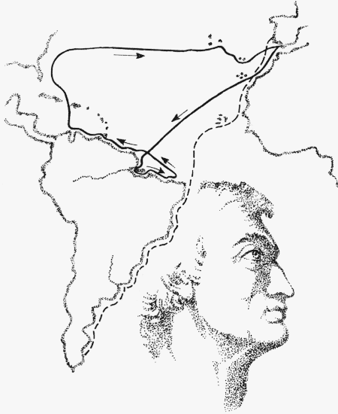

Using the combined information and insights from the readings
and knowledge of your group members complete the following
questions, and comparative graphs. To complete the handout
correctly you will need to rely on the combined information
provided by each group member. Following completion of the
assignment you will be asked to rate each members contribution
and efforts to complete the assignment.

Individual  Explorer  or  Country | For whom did they sail or work? | Place of Origin i.e Where were they born? | Fate  How were they viewed by people at that time | Positive Consequences  What were the positive results of their work? | Negative  Consequences  What were the negative results of their work? | Interesting Facts  (How did they die; what did they do; something interesting about them, etc.)
Ferdinand & Isabel

King/Prince Henry

Christopher
Columbus

Amerigo Vespucci

Vasco Núñez de Balboa

Ferdinand Magellan

Define the following terms:
1. Monopoly:

2. Reconquista:

3. Line of Demarcation:

4. Treaty of Tordesillas:

5. Circumnavigate:

6. Strait:

7. Colombian Exchange:

Answer the following questions using all of the information available to you:

8. What were five negative effects of European exploration? Explain

9. What were five positive effects of European exploration? Explain

10. Do you believe the Explorers were Heroes (good guys) or Villains (bad guys)? Explain your answer

Spain Explores A New World
Read pages 42-43 in the “Call to Freedom” textbook. In your listening guide, identify or define the following terms or people:

Conquistadores:

Hernán Cortés:

Moctezuma II:

Francisco Pizarro:

Juan Ponce de León:

Hernando de Soto:

Francisco Vásquez de Coronado:

Spain Explores a New World
- Watch the “Smallpox” film clip. In your listening guide answer the following two questions:
- List at least two reasons why Cortes was able to defeat the mighty Aztecs.
1.

2.

- List two examples of how Spain influenced (changed) the lives of Native Americans of the New World (the Americas)
1.

2.
Spain Explores a New World
What does this mean historically?
Watch the Conquest of America “The Southwest.” When finished answer the following questions:
1. Why did Francisco Vasquez de Coronado want to explore the Southwest? What did he hope to find? How far did he travel?

2. How did the Indians of the Southwest treat Coronado on his expedition to the Southwest? Explain

List three reasons why the explorers/conquistadores wanted to go to the new world (America)?
1.

2.

3.

List three results of their travels? (What did they do?)
1.

2.

3.

The Columbian Exchange
- The Columbian exchange is defined as the exchange of _____________ _____________ from the New World to the Old World and the _____________World to the _____________World
The Columbian Exchange: Global Corporate Structure (Ideas)
- The Columbian Exchange created an _____________ association _____________ and _____________
- For Europe, America was a laboratory for unmonitored capitalistic exploitation. The _____________ organizations coupled with ideas of liberty to stimulate investment and profit sharing that ultimately led to many present corporate structures at global levels.

The Columbian Exchange
- “After 1492, the world’s ecosystems collided and mixed as European vessels carried thousands of species to new homes across the oceans. The Columbian exchange is why there are tomatoes in Italy, oranges in Florida, chocolates in Switzerland, and hot peppers in Thailand. It is arguably the __________________________ since the death of the dinosaurs.” National Geographic May 2007

Think About It
What do you think were the most important goods, peoples and ideas exchanged in the Columbian Exchange? Why? Explain your answer.
________________________________________________________________________________________________________________________________________________________________________________________________________________________________________________________________________________________________________________________

Think About It
Does might make right? Explain your answer in context of what happened in Spanish America. Be prepared to transfer your answer to a discussion on current events and issues.
________________________________________________________________________________________________________________________________________________________________________________________________________________________________________________________________________________________________________________________

Enduring Understanding: Students will recognize the role religion played in the development of American History

Essential Questions:
1. Where & when were the Pueblos colonized?
2. Who was involved and what role did they play in the settlements?
3. Why were the Pueblos colonized?
4. How did it impact the Native culture?

- Where & when were the Pueblos colonized?:

- In 1528-1538 Cabeza de Vaca, and 3 other lost explorers, made their way ______________ to ____________ and from Houston to _________________by land. They told stories of Cities of Gold.
Mapping Activity:
Use the map below to trace the routes followed by Cabeza de Vaca, Coronado and Juan de Onate, as they travelled and later settled from Meso-America to the American South-West. Label all present day states that they travelled through..
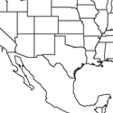

- Where & when were the Pueblos colonized?:

- In ________________ Coronado explored the American South West

- Who was involved and what role did they play in the settlements?
  - Juan de Oñate founded the first Spanish settlement in _________________, in the present day United States in _________________.
    - Oñate created the "The Royal Road,"
      - A 700 mile trail from New Spain to _____________________.
    - With Oñate were Franciscan missionaries (counter-reformation) they established _________________ throughout New Mexico. They were required by law to read the “Requirimiento” at every settlement they visited.
      - Onate tried to make money but failed, the Spanish government chose to keep the missions open rather than “offend God”.
        - Spain spent 90 pesos in administrative costs for every peso produced in NM
    - Onate was made the first ____________________ of the new province of Santa Fe de Nuevo Mexico.
      - Oñate’s brother was sent to deal with ________________Natives.
        - 100’s ____________ all men over 25 years of age had foot amputated
How did it impact the Native culture?
- Colonists given royal rights as ______________________
  - The crown granted a person a number of natives for whom they were to take responsibility.
    - _______________ the natives; _______________Spanish & Catholicism.
    - Exact (or take) _________________ from the natives (labor or goods).
- Missions had little success.
  - Mixed mission of grace w/demands for food, clothing and labor.
  - Some missions survived.
- Pueblo Revolt in ______________ the Spanish (governors, colonists and missionaries) forced to flee.
  - Revolt led by Popay
- 1692 the Spanish returned.
  - Spain continued to govern Southwest until 1820 (Mexican Revolution), claimed by Mexico until 1846.

Write a Cinquin Poem

Write a Cinquin poem related to the Spanish involvement in the Americas. Follow the format presented below. Be prepared to present your poem with others.

Line 1: One noun
Line 2: Two adjectives
Line 3: Three “ing” words
Line 4: A four word phrase
Line 5: Another word
(synonym) for 1st word

Example:

Columbian Exchange
Rich, Poor
Helping, Adapting, Dying
Moved Goods, Ideas, & People
The world was changed
Trade

WalkAway Preparation
This required homework assignment is designed to help you prepare for the WALKAWAY exam on Europe to the Americas. The homework consists of three steps. Step 1: Review. Step 2: Complete Practice online exam on UCUTIPS. Step 3: Gather Parent Signature. This assignment must be completed prior to the exam!
Step 1: Review (1) Read your listening guide The Spanish in America. (2) While reading, pay attention to the blanks, make sure you know and understand the information.
Step 2: Complete Practice online exam.
1. Go to: http://www.ucutips.org/~willowhistory/
2. Access the Native American Practice Exam from the left hand tool bar, under: “Practice WalkAway Exams Folder” .
3. Open the Spanish in America Practice exam.
4. Use the drop down menus to access the test.
A. Follow the format below.
B. Under the Teacher drop down menu, find your teacher’s name.
C. Under the Class drop down menu find your class number
D. Under the Name drop down menu, find your name, login and start.
E. While taking the practice exam write down the questions and answers YOU MISS (write the entire question not the number).
Top of Form
The Spanish In America Practice Walkaway | 
Open Book TestID: 201066
30 Question(s)
30 - Forced Response

District:
School:
Teacher: | Elizabeth Robertson or Cindy Ness
Class:
Name:


If you are unable to do a detailed login, do a simple login.

Step 3 Gather Parent Signature: Show your parents your written notes from the practice exam. Review these notes with your parents. If necessary have them quiz you about the information with which you need additional help. Have them sign below once completed

Student name: _____________________________________
*Parent name: ______________________________________

*We appreciate your involvement in your child’s learning. We are aware some students do not have access to the internet. Please note the test is available anywhere students can access the internet, i.e. the school and public library, as well as in our classroom Wednesdays and Thursdays after school.
BELOW, write down all of the questions you missed with the full, detailed answers. You may use an additional sheet of paper if needed.

Appendix: The Spanish in the Americas

Tenochtitlan, the Aztec Metropolis

The beginnings of the Aztec capital were very humble. It was founded on a low-lying island so undesirable that other tribes had not bothered to occupy it. The indigenous chronicles describe the difficulties with which the Aztecs managed to build a few miserable huts and a small altar to their supreme deity, the war-god Huitzilopochth. But their fierce will overcame every obstacle. Less than two centuries later, the Spanish conquistador Bernal Diaz del Castillo thought that the wonders he beheld must be a dream. The Spaniards had been welcomed into the city as guests of Motecuhzoma, and a party of them-led by Cortes-climbed up to the flat top of the pyramid on which the main temple was built. They were met by the Aztec king himself, who pointed out the various sights.

So we stood looking about us, or that huge and cursed temple stood so high that from it one could see over everything very well, and we saw the three causeways which led into Mexico, that is the causeway of Iztapalapa by which we had entered four days before, and that of Tacuba, and that of Tepeaquilla, and we saw the fresh water that comes from Chapultepec which supplies the city, and we saw the bridges on the three causeways which were built at certain distances apart through which the water of the lake flowed in and out from one side to the other, and we beheld on that great lake a great multitude of canoes, some coming with supplies of food and others returning loaded with cargoes or merchandise; and we saw that from every house of that great city and of all the other cities that were built in the water it was impossible to pass from house to house, except by drawbridges which were made of wood or in canoes; and we saw in those cities Cues [temples] and oratories like towers and fortresses and all gleaming white, and it was a wonderful thing to behold; then the houses with flat roofs, and on the causeways other small towers and oratories which were like fortresses.
After having examined and considered all that we had seen we turned to look at the great market place and the crowds of people that were in it, some buying and others selling, so that the murmur and hum of their voices and words that they used could be heard more than a league off. Some of the soldiers among us who had been in many parts of the world, in Constantinople, and all over Italy, and in Rome, said that so large a market place and so full of people, and so well regulated and arranged, they had never beheld before.

The Plague Ravages the City
An account of ravages of small pox in Tenochtitlan (the capital of the Aztecs) following the invasion by the Spanish

“While the Spaniards were in Tlaxcala, a great plague broke out here in Tenochtitlan. It began to spread during the thirteenth month and lasted for seventy days, striking every where in the city and killing a vast number of our people. Sores erupted on our faces, our breasts, our bellies; we were covered with agonizing sores from head to foot.

The illness was so dreadful that no one could walk or move. The sick were so utterly helpless that they could only lie on their beds like corpses, unable to move their limbs or even their heads. They could not lie face down or roll from one side to the other. If they did move their bodies, they screamed with pain.

A great many died from this plague, and many others died of hunger. hey could not getup to search for food, and everyone else was too sick to care for them, so they starved to death in their beds.

Some people came down with a milder form of the disease; they suffered less than the others and made a good recovery. But they could not escape entirely. Their looks were ravaged, for wherever a sore broke out, it gouged an ugly pockmark in the skin. And a few of the survivors were left completely blind.

The first cases were reported in Cuatlan. By the time the danger was recognized, the plague was so well established that nothing could halt it, and eventually it spread all the way to Chalco. Then its virulence diminished considerably, though there were isolated cases for many months after. The first victims were stricken during the fiesta of Teotlecco and the faces of our warriors were not clean and free of sores until the fiesta of Panquetzaliztli.”

The Spaniards Return

And now the Spaniards came back again. They marched here by way of Tezcoco, set up headquarters in Tlacopan and then divided their forces. Pedro de Alvarado was assigned the road to the Tlatelolco quarter as his personal responsibility, while Cortes himself took charge of the Coyoacan area and the road from Acachinanco to Tenochtitlan proper. Cortes knew that the captain of Tenochtitlan was extremely brave.

The first battle began outside Tlatelolco, either at the ash pits or at the place called the Point of the Alders, and then shifted to Nonohualco. Our warriors put the enemy to flight and not a single Aztec was killed. The Spaniards tried a second advance but our warriors attacked them from their boats, loosing such a storm of arrows that the Spaniards were forced to retreat again.

Cortes, however, set out for Acachinanco and reached his goal. He moved his headquarters there, just outside the city.

Heavy fighting ensued, but the Aztecs could not dislodge him.

The Spaniards Launch Their Brigantines

Finally the ships, a dozen in all, came from Tezcoco and anchored near Acachinanco. Cortes went out to inspect the canals that traversed the causeways, to discover the best passages for his fleet. He wanted to know which were the nearest, the shortest, the deepest, the straightest, so that none of his ships would run aground or be trapped inside. One of the canals across the Xoloco thoroughfare was so twisted and narrow that only two of the smaller ships were able to pass through it.

The Spaniards now decided to attack Tenochtitlan and destroy its people. The cannons were mounted in the ships, the sails were raised and the fleet moved out onto the lake. The flagship led the way, flying a great linen standard with Cortes' coat of arms. The soldiers beat their drums and blew their trumpets; they played their flutes and chirimias and whistles.

When the ships approached the Zoquiapan quarter," the common people were terrified at the sight. They gathered their children into the canoes and fled helter-skelter across the lake, moaning with fear and paddling as swiftly as they could. They left all their possessions behind them and abandoned their little farms without looking back.

Our enemies seized all our possessions. They gathered up everything they could find and loaded it into the ships in great bundles. They stole our cloaks and blankets, our battle dress, our tabors and drums, and carried them all away. The Tlatelolcas followed and attacked the Spaniards from their boats but could not save any of the plunder.

When the Spaniards reached Xoloco, near the entrance to Tenochtitlan, they found that the Indians had built a wall across the road to block their progress. They destroyed it with four shots from the largest cannon. The first shot did little harm, but the second split it and the third opened a great hole. With the fourth shot, the wall lay in ruins on the ground.

Two of the brigantines, both with cannons mounted in their bows, attacked a flotilla of our shielded canoes. The cannons were fired into the thick of the flotilla, wherever the canoes were crowded closest together. Many of our warriors were killed outright; others drowned because they were too crippled by their wounds to swim away. The water was red with the blood of the dead and dying. Those who were hit by the steel arrows were also doomed; they died instantly and sank to the bottom of the lake.

During this time the Aztecs took refuge in the Tlatelolco quarter. They deserted the Tenochtitlan quarters all in one day, weeping and lamenting like women. Husbands searched for their wives, and fathers carried their small children on their shoulders. Tears of grief and despair streamed down their cheeks.

The Tlatelolcas, however, refused to give up. They raced into Tenochtitlan to continue the fight and the Spaniards soon learned how brave they were. Pedro de Alvarado launched an attack against the Point of the Alders, in the direction of Nonohualco, but his troops were shattered as if he had sent them against a stone cliff. The battle was fought both, on dry land and on the water, where the Indians shot at the Spaniards from their shielded canoes. Alvarado was routed and had to draw back to Tlacopan.

On the following day, two brigantines came up loaded with troops, and the Spaniards united all their forces on the outskirts of Nonohualco. The soldiers in the brigantines came ashore and the whole army marched into the very heart of Tenochtitlan. Wherever they went, they found the streets empty, with no Indians anywhere in sight.

The Spanish blockade caused great anguish in the city. The people were tormented by hunger, and many starved to death. There was no fresh water to drink,' only stagnant water and the brine of the lake, and many people died of dysentery. The only food was lizards, swallows, corncobs and the salt grasses of the lake. The people also ate water lilies and the seeds of the colorin, and chewed on deerhides and pieces of leather. They roasted and seared and scorched whatever they could find and then ate it. They ate the bitterest weeds and even dirt.

Nothing can compare with the horrors of that siege and the agonies of the starving. We were so weakened by hunger that, little by little, the enemy forced us to retreat. Little by little they forced us to the wall.

The Flight from the City

Once again the Spaniards started killing and a great many Indians died. The flight from the city began and with this the war came to an end. The people cried: "We have suffered enough! Let us leave the city! Let us go live on weeds! " Some fled across the lake, others along the causeways, and even then there were many killings. The Spaniards were angry because our warriors still carried their shields and macanas.

Those who lived in the center of the city went straight toward Amaxac, to the fork in the road. From there they fled in various directions, some toward Tepeyacac, others toward Xoxohuiltitlan and Nonohualco; but no one went toward Xoloco or Mazatzintamalco. Those who lived in boats or on the wooden rafts anchored in the lake fled by water, as did the inhabitants of Tolmayecan. Some of them waded in water up to their chests and even up to their necks. Others drowned when they reached water above their heads.

The grownups carried their young children on their shoulders. Many of the children were weeping with terror, but a few of them laughed and smiled, thinking it was great sport to be carried like that along the road.

Some of the people who owned canoes departed in the daytime, but the others, the majority, left by night. They almost crashed into each other in their haste as they paddled away from the city.

The Spaniards Humiliate the Refugees

The Spanish soldiers were stationed along the roads to search the fleeing inhabitants. They were looking only for gold and paid no attention to jade, turquoise or quetzal feathers. The women carried their gold under their skirts and the men carried it in their mouths or under their loincloths. Some of the women, knowing they would be searched if they looked prosperous, covered their faces with mud and dressed themselves in rags. They put on rags for skirts and rags for blouses; everything they wore was in tatters. But the Spaniards searched all the women without exception: those with light skins, those with dark skins, those with dark bodies.

A few of the men were separated from the others. These men were the bravest and strongest warriors, the warriors with manly hearts. The youths who served them were also told to stand apart. The Spaniards immediately branded them with hot irons, either on the cheek or the lips.

The day on which we laid down our shields and admitted defeat was the day 1-Serpent in the year 3-House. When Cuauhtemoc surrendered, the Spaniards hurried him to Acachinanco at night, but on the following day, just after sunrise, many of them came back again. They were dressed for battle, with their coats of mail and their metal helmets, but they had left their swords and shields behind. They all tied white handkerchiefs over their noses because they were sickened by the stench of the rotting bodies.

Source: The texts in reading have been taken from three different indigenous sources. The first selection, by Sahagun's native informants, gives an eloquent description of the tragic scenes that accompanied the taking of the city. The second selection is from the XII relacion by Alva Ixthlilxochitl. The last selection is from the VII relacion by Chimalpain, and was translated from Nahuatl to Spanish by Miguel Leon-Portilla.

Requerimiento
The Spanish Requirement of 1513 ("El Requerimiento") was a declaration by the Spanish monarchy of its divinely ordained right to take possession of the territories of the New World and to subjugate, exploit and, when necessary, to fight the native inhabitants. The Requirement was read in Spanish to Native Americans to inform them of Spain’s rights to conquest. Those who subsequently resisted conquest were considered to harbor evil intentions. The Spaniards thus considered those who resisted as defying God’s plan, and so used Catholic theology to justify their conquest.

“On the part of the King, Don Fernando, and of Doña Juana, his daughter, Queen of Castile and León, subduers of the barbarous nations, we their servants notify and make known to you, as best we can, that the Lord our God, living and eternal, created the heaven and the earth, and one man and one woman, of whom you and we, and all the men of the world, were and are all descendants, and all those who come after us.
Of all these nations God our Lord gave charge to one man, called St. Peter, that he should be lord and superior of all the men in the world, that all should obey him, and that he should be the head of the whole human race, wherever men should live, and under whatever law, sect, or belief they should be; and he gave him the world for his kingdom and jurisdiction.
One of these pontiffs, who succeeded St. Peter as lord of the world in the dignity and seat which I have before mentioned, made donation of these isles and Terra-firma to the aforesaid King and Queen and to their successors, our lords, with all that there are in these territories,
Wherefore, as best we can, we ask and require you that you consider what we have said to you, and that you take the time that shall be necessary to understand and deliberate upon it, and that you acknowledge the Church as the ruler and superior of the whole world,
But if you do not do this, and maliciously make delay in it, I certify to you that, with the help of God, we shall powerfully enter into your country, and shall make war against you in all ways and manners that we can, and shall subject you to the yoke and obedience of the Church and of their highnesses; we shall take you, and your wives, and your children, and shall make slaves of them, and as such shall sell and dispose of them as their highnesses may command; and we shall take away your goods, and shall do you all the mischief and damage that we can, as to vassals who do not obey, and refuse to receive their lord, and resist and contradict him: and we protest that the deaths and losses which shall accrue from this are your fault, and not that of their highnesses, or ours, nor of these cavaliers who come with us .”

Source: Cited from the Smithsonian online library

