Name: _____________________ Period: __________

Utah in the Cold War & Space Race Notes
- Definition of Communism: A system of government where the government plans and ________ the economy and a single, often authoritarian party holds all the _______, claiming to make progress toward a higher social order in which all goods are ________ ________ by the__________.

- Looking at the map, what two countries were the main powers involved in the Cold War:
  - _______________________
  - _______________________

- In your own words, what was the Cold War?

- Did the USSR & the USA ever meet officially in battle?
YES NO
- What are four ways that Utah was impacted by the Cold War:
- ________________________________________
- ________________________________________
- ________________________________________
- _____________________________________
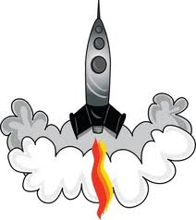

- How did the Soviet Union & the USA compete in the space race?

- After watching the movie clip, how did the Space Race impact the nation’s pride and confidence?

