Utah War Effort Readings: As you read your selected section, look for key facts to share with the class on what you learn. How did World War II affect Utah? What are key things to remember?

#1 Armed Forces- 1000s of Utahans left their homes & fought in armed forces around the world
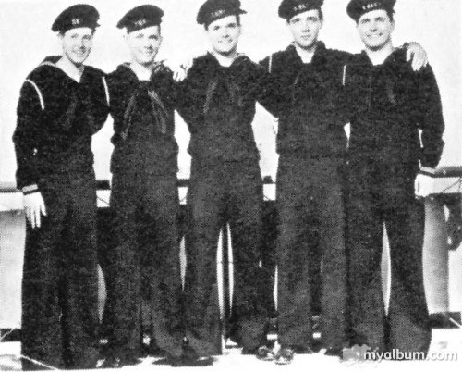
World War II took the lives of many Utahns, but no family in the state sacrificed more for the Allied cause than Alben and Gunda Borgstrom of Thatcher, Box Elder County. Four of the five sons they sent off to battle died within a six-month period during 1944. "Few families in American history have been called upon to make such a tremendous sacrifice for the cause of freedom and liberty," one speaker noted at ceremonies honoring the Borgstrom brothers in 1946.

LeRoy Elmer Borgstrom attended Bear River High School and was a farmer before the war. He was shipped overseas in March 1944 and participated in battles in Africa and Italy. He was killed in action in Italy on June 22, 1944.

Clyde Eugene Borgstrom enlisted in the Marines on October 14, 1940, before the U.S. was officially involved in the war, and was among the first Bear River Valley men to enter the service. He was killed in action on March 17, 1944, at Guadalcanal, Solomon Islands.

Twin brothers Rolon Day and Rulon Jay Borgstrom were born May 5, 1925, in Tremonton. The boys were drafted into the Army on July 7, 1943, two weeks after their high school graduation. Rolon trained at Camp Walters, Texas, where he passed an examination to enter the Air Corps. After further training in mechanics, aerial gunnery, and combat, he was shipped overseas in June 1944 as an aerial gunner. He died in England on August 8, 1944, of injuries suffered during a bombing mission over France and Germany. Rulon, also a gunner on a heavy bomber, was killed in action on August 25, two and a half weeks after his twin. Rulon, initially reported as missing in action, was not confirmed dead for several months.

Boyd Carl Borgstrom, born July 21, 1921, in Thatcher, had enlisted on October 14, 1940, with his brother Clyde. Upon news that his fourth brother was missing in action, Boyd was shipped from the South Pacific to Camp LeJeune, North Carolina, where he as discharged on October 7, 1944.

In April 1959 the four Borgstrom brothers were honored when the Army named a reserve training center in Ogden in their honor. Gunda Borgstrom accepted a plaque with pictures of her sons at the dedication ceremony and saw a trophy case with her sons' records unveiled in the training center.
Utah War Effort Readings: As you read your selected section, look for key facts to share with the class on what you learn. How did World War II affect Utah? What are key things to remember?

#2 Boot Camps & Bases- Utah was an ideal place for military training
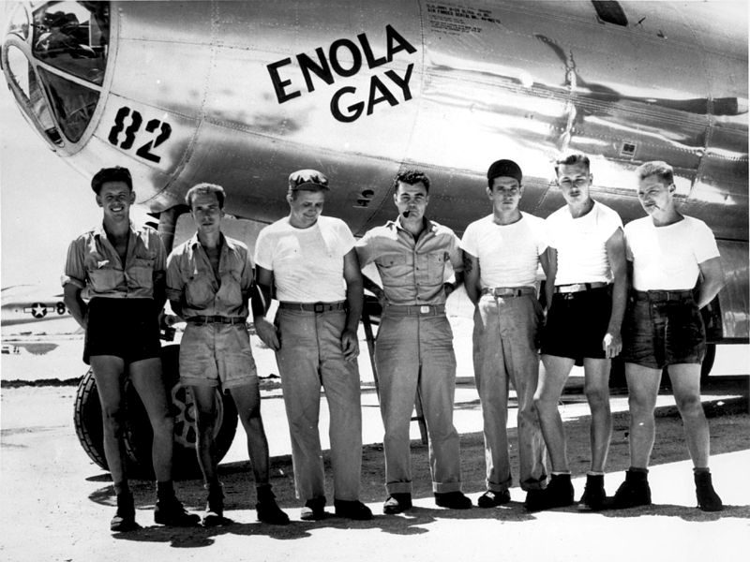
During World War II, the United States Army Air Force (USAAF) established numerous airfields in Utah for training pilots and aircrews of USAAF fighters and bombers.
Most of these airfields were under the command of Second Air Force or the Army Air Forces Training Command AAFTC). (However the other USAAF support commands (Air Technical Service Command (ATSC); Air Transport Command (ATC) or Troop Carrier Command) commanded a significant number of airfields in a support roles.
One such base was Wendover Air Force Base. During World War II it was a training base for B-17 and B-24 bomber crews .From March 1942 through April 1944 Wendover AAF hosted twenty newly-formed B-17 and B-24 groups during one phase of their group training. In March 1942, heavy bomber training was a two-phase program, with each phase being six weeks. Later, the training was changed to a three-phase program, and each stage lasted four weeks. Wendover would do the second-phase training.
At Wendover, these groups utilized the huge Wendover Bombing and Gunnery Range southeast of the airfield. For a short time, beginning in May 1944, Wendover field trained fighter groups. However, this was abruptly canceled in September 1944. In September, Boeing B-29 Superfortresses arrived on the field, as part of an operation code named " Silverplate". They would begin preparations for the dropping of the world's first atomb bomb. The 509th's training was classified Top Secret; therefore the desert isolation of Wendover Field was ideal. This B-29 unit eventually dropped the Hiroshima and Nagasaki atomic bombs to end World War II in August of 1945.

Utah War Effort Readings: As you read your selected section, look for key facts to share with the class on what you learn. How did World War II affect Utah? What are key things to remember?

#3 Courageous Women in the Workforce- “Rosie the Riveters” helped war production
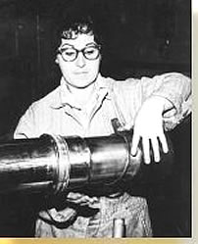
Women were employed at all Utah military facilities, including the Ogden Arsenal, the Utah General Depot, the Ogden Air Materiel Area at Hill Field, the Naval Supply Depot at Clearfield, and the Tooele Ordnance Depot. Women also worked at the Remington Arms Company, the Eitel McCullough Radio Tube Plant, and the Standard Parachute Company - private industries with military contracts. Furthermore, women substantially contributed to agricultural production in the state.

The call for women to enter the work force escalated as more men marched off to war. For example, spanning the Deseret News want ads in a banner headline during World War II was, "One Solution For Your Personnel Problem--Hire Women." The Ogden Standard Examiner declared in 1942: "It is in the nature of patriotic duty of the highest order to apply at once at the personnel office of the Arsenal...and Ogden women of all ages are urged to lay aside all considerations of need for earning money and come to the Arsenal to make a direct and vital contribution to the United Nations victory in the war." The calls for women workers were successful. Utah women responded to patriotic appeals and to promises of good salaries, pleasant conditions, and steady work obtainable without experience. Women constituted 17.6 percent of the Utah labor force in 1940 and 36.8 percent by 1944. Government war plants employed a larger percentage of women than any other industrial concern. Still more were needed. On November 1, 1944, the local Minute Women Organizations telephoned house to house in search of women to work outside the home. Both times they were unable to bring more women into the work force, indicating that all the women who could or wanted to had taken jobs.

Perhaps the most interesting public comment on women is the following excerpt, "Because Ogden Arsenal employs a large number of women a realistic survey of female employment has been made available to Colonel Nickerson by Army ordnance personnel. Here is what battle-tough experts discovered. Women have greater finger dexterity than men; greater patience; greater enthusiasm. Women will accept ninety-nine percent responsibility, but they always like to receive a final O.K. on their work from a man. Women want their job glamorized for them. Women do not mind getting their hands and faces dirty, but the lack of beauty shops in the community will cause a serious personnel problem. Women take instruction and direction in a far more personal manner than men. Women are patriotic without cynicism."

Utah War Effort Readings: As you read your selected section, look for key facts to share with the class on what you learn. How did World War II affect Utah? What are key things to remember?

#4 Daily Rationing & Gardening- Utahans sacrificed food & supplies & planted victory gardens to help support the war
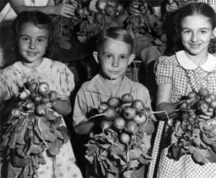
County rationing boards were organized to establish and monitor the numerous commodities rationed for agriculture and consumer consumption...As the war progressed, additional commodities and consumer goods of all kinds were added to the rationing system--gas, meat, sugar, cheese, and nylon hosiery, to mention a few. Ammunition was also rationed; purchasing bullets for hunting required a coupon. Everyone was encouraged to conserve, and rationing stamps were common.

Along with rationing came various salvage and recycling efforts. People were encouraged to save grease, rubber, tin, metals, and paper. Labrum's gas station in Roosevelt was the collection center for used tires and other rubber items. In one salvage project the county collected twelve tons of paper. Children in the county participated in saving and collecting scraps of tinfoil. Emptied tin tubes of toothpaste had to be exchanged at stores before a new tube could be purchased. Salvage bins for small items were found in all stores of the county.

Families in the county were encouraged at school and in church to plant "victory gardens" to supplement their food supply and make them less dependant upon national food supplies. Families living in Roosevelt, Myton, and Duchesne were asked to convert some of their lawns to gardens. Articles in the Roosevelt Standard encouraged and informed people how to best utilize some of their yard in gardening. The county Future Farmers of America (FFA) assisted people in the tasks of getting started. Young children, Boy Scout troops, 4-H clubs, and others were asked to collect milkweed pods. Fiber from the milkweed pods was used to fill lifejackets of marines and navy personnel. The Roosevelt Standard reminded the children that by collecting the milkweed pods they might be saving the life of their father, older brother, uncle, or friend.

