U.S. WESTWARD EXPANSION MAP
Color the different expansion sections on the map as listed below. Then carefully cut out each section. You will be attaching and labeling each section to a booklet we will make next.
(1)The U.S. in 1783: RED (2) The Northwest Territories 1819: BLUE (3) The Southern States 1787: PURPLE (4) The Louisiana Purchase 1803: BROWN
(5)The Texas Annexation 1845: YELLOW (6) The Oregon Territory 1846: DARK GREEN (7) The Mexican Cession 1848: PINK (8) The Gadsden Purchase 1853: ORANGE
(9) Alaska 1867: Any color, or shade of color you have not yet used (10) Hawaii 1898: Any color or shade of color you have not yet used
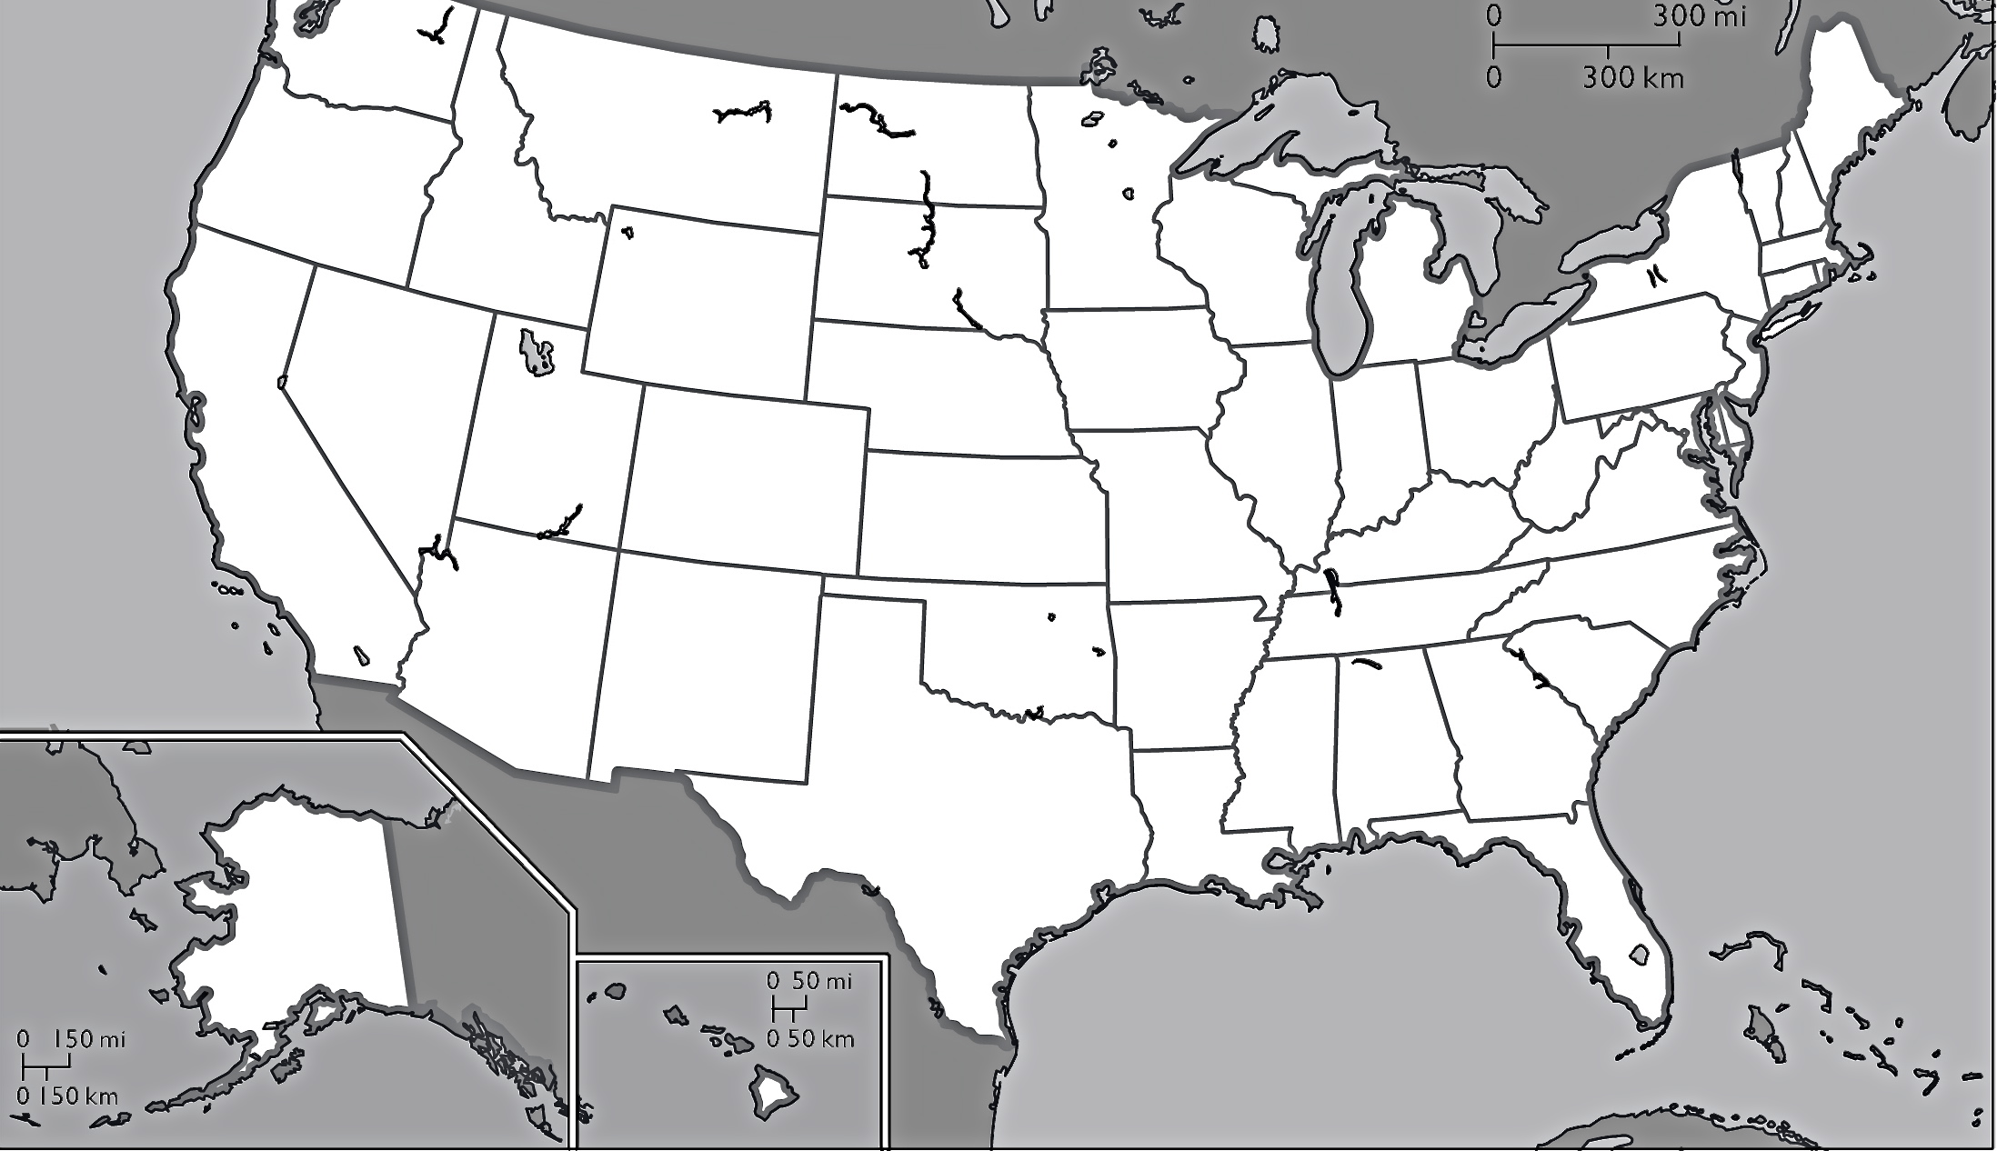
(3)
(2)
(9)
(10)
(8)
(7)
(6)
(5)
(4)
(1)

