World War I & Mining Study Guide

Students will describe the impact of World War I on Utah and Utah’s mining history.

- Timeline- Where does World War I & Mining fit in our unit? (Complete the missing events).

Mining ___________ Roaring Twenties ____________ Great Depression World War II
____________________________________________________________________________
1900s 1914-1918 1920-1929 October 29th 1929 1929-1940s 1939-1945

2. Read page 212-213 in your Utah History Textbook & complete the below questions.
- How was Camp Williams in Utah (nearby Lehi) used during World War I?

- How did Utahns at the home front support their troops fighting in Europe?

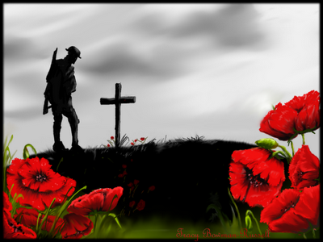
- World War I Poem: “In Flander’s Field.” Summarize what the poem is talking about. (2 complete sentences)

- World War I Basics:
  - When: 1914- ___________
  - Nickname: “The ________ War”or the War to End All Wars
  - Allies: Russia, France, Great Britain, United States
  - Central Powers: Germany, Austria-Hungary, Turkey, Bulgaria
  - Trigger to war: Assassination of ____________ __________ of Austria-Hungary

- 4 main causes to World War I: MAIN
  - Militarism __________________________________________________
  - Alliances ____________________________________________________
  - Imperialism __________________________________________________
  - Nationalism __________________________________________________

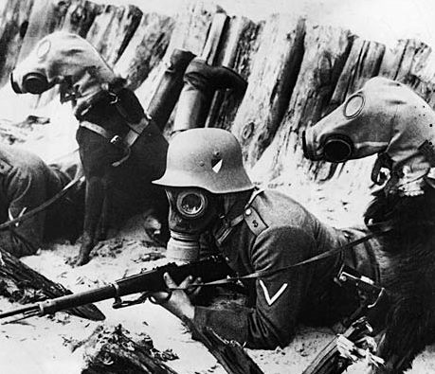
- List 3 new technologies used for the first time during World War I:
  - ______________________________________
  - ______________________________________
  - ______________________________________

- Mining in Utah: Read p207 in your Utah history textbook & answer the 3 questions:
- Circle all of the products that have been mined in Utah:

a. Copper b. Coal c. Silver d. Gold e. All

- How were people in Utah affected by mining?

- Who were the Silver Kings? Describe.

- Read the below text & discuss how the Scofield Mine Disaster impacted Utah:

“Utah’s worst mine disaster killed 246 people, including 61 Finnish immigrants and 20 boys. Some of the miners were killed by an explosion of coal dust inside the mine. In an adjoining mine, men heard an explosion and tried to rush out but instead met deadly carbon monoxide gas. It was a time of great mourning in the mining towns. In those days, the mining companies didn’t take responsibility for accidents or deaths but the company did pay for a set of new burial clothes, a coffin, $500 to each miners’ family. The disaster prompted a labor strike a following winter. Through the following years workers fought for more safety and workers compensation (money) when a miner was injured or killed.” p208 (Utah history textbook).

Notes:

Write a one page paper with 2 paragraphs:

Paragraph 1: Explain some of the details of World War I. How was Utah impacted by this “War to end all wars?

Paragraph 2: What are some of the dangers of mining? What happened in the Scofield Mining Disaster? Explain.

