World War II & Nuclear Testing Study Guide

Objective: Students will evaluate Utah’s role during World War II and the effect of nuclear testing in Utah.

Big Ideas: WWII impacted Utah, and Utahans impacted the course of WWII.
One individual or groups of individuals can make a difference: for good or for bad

Introduction: Read the , “The Utah Man.” What was it & how did this individual Utahan impact World War II? (2 sentences)

I. World War II Basics 101

- What years was it? From ________ to _________

I.1 Timeline Pt 1
On the following time line complete the information in the blanks, in the boxes provided, write at least one additional piece of information shared by the instructor.

_________________ attack _________________
U.S declares war on _______________________
Hitler & ______________
Form the __________ powers

Synagogues & ______________ are
______________ by Nazi mobs in ___________
(_______________________)

1935 1936 1937 1938 1939 1940 1941

______ declares
War on ______and _________ and invades France
Hitler (Germany) _________
Poland .

______________________ invades and annexes
______________________

I.2 United States and Utah enter W.W.II
Read pages 237-246 in the Utah History textbook (including the textboxes and side margins) when finished answer the following questions in full sentences, providing details when necessary to support your answer. Answers should be written neatly, using correct grammar and penmanship.

1. What countries were the major Axis Powers? What countries were the Allied Powers?

2. What happened at Pearl Harbor? Please provide details, and fill in the entire space.

3. List and explain three reasons why Utah was in such a good position to help the war effort?
A.

B.

C.

4. Explain how rationing worked?

5. What kinds of items were in short supplies during the war?

6. List some ways in which women helped the war effort? Give specific details

I. World War II Basics 101 (Pt. II)

- What countries were the Axis powers? _____________, _____________, ____________.
- What countries were the Allied powers? ___________, ____________, _____________.
- How did the war start? _____________________________________________________
- How did the United States get involved in World War II? _________________________.

II. Utah War Effort at Home-

II. 1 THE ABC’S! Read your given section & be prepared to share with the class what you learn. While reading list important details under each letter to help you remember how Utah was affected by World War II.

  - Armed Forces- 1000s of Utahans left their homes & fought in armed forces around the world
    - ____________________________________________________________
    - ____________________________________________________________
  - Boot Camps & Bases- Utah was an ideal place for military training
    - ____________________________________________________________
    - ____________________________________________________________
  - Courageous Women in the Workforce- “Rosie the Riveters” helped war production
    - ____________________________________________________________
    - ____________________________________________________________
  - Daily Rationing & Gardening- Utahans sacrificed food & supplies & planted victory gardens to help support the war
    - ____________________________________________________________
    - ____________________________________________________________

What did you learn from you peers:
Armed Forces:

Boot Camps & Bases:

Courageous Women:

Daily Rationing & Gardening:

I.1 Timeline Pt 2
On the following time line complete the information in the blanks, in the boxes provided, write at least one additional piece of information shared by the instructor.
_____________ Conference, Mussolini _______, Hitler commits ____________, Berlin _________, Germany signs unconditional ______________

German 6th Army ______________________ at Stalingrad- the ________________ point of the war in _____________________.

1942 1943 1944 1945

D-Day- __________ invade _______________ Germany launches counteroffensive in ______________- Battle of the ______________

U.S. and ___________________ land in French ______________ _______________

A- bombs dropped on _____________ and Nagasaki, __________ surrenders V-J Day.

III. World War II Basics Pt II III.1 Complete the chart below with complete sentences.

Term: | Definition: (Who, what, when, where) | Why does it matter/ How did it impact Utah?
Holocaust

Navajo Code Talkers
D-Day
Internment Camps
V-E Day & V-J Day

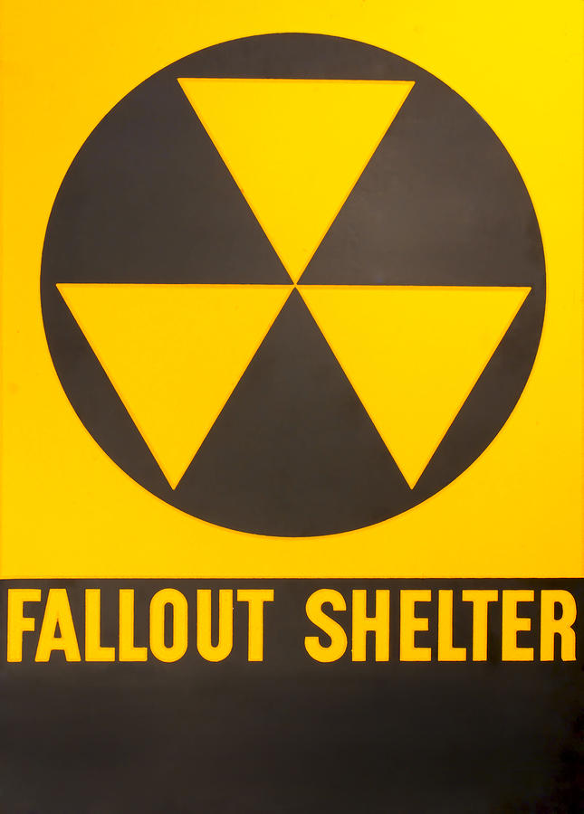
- Nuclear Testing: What was it? (complete sentences)

- How has it affected people in Utah?

- Downwinders refers to individuals and communities who are _________ to__________ contamination or nuclear ________ from atmospheric or underground nuclear weapons testing, and nuclear accidents.

- After reviewing the primary accounts of Utah downwinders, pretend a member of your family was affected by the nuclear testing in Utah and has had many unexplainable health problems. Many call your family member a, “downwinder.” Write a letter to the United States government and express your concern and alarm about nuclear testing and what you think they should do to fix the problem and help your family. (8 sentences at least)

IV. Internment Camps

Read pages 247-249 in the Utah History textbook (including the textboxes and side margins) when finished answer the following questions in full sentences, providing details when necessary to support your answer. Answers should be written neatly, using correct grammar and penmanship.

1. For what reasons were Japanese Americans forced to move to camps such as Topaz?

2. Mine Okobo wrote a book about her experiences at Topaz. Do you agree or disagree with her? Explain you answer. Give numerous examples from your own life and/ or from the novel “Journey to Topaz” to support your opinion.

V. The Big Ideas:
One individual or groups of individuals can make a difference: for good or for bad

Positive | Negative
Who? & How? | Who? & How?

